

|  |
| --- |
| **Software Engineering and Project Management** |
| Lab Manual |
| **Department of Computer Science and Engineering**  **The NorthCap University, Gurugram** |

**Software Engineering and Project Management**

**CSL229**

**Dr. Sujata**



Department of Computer Science and Engineering

NorthCap University, Gurugram- 122001, India

Session 2021-22

*Published by:*

**School of Engineering and Technology**

**Department of Computer Science & Engineering**

**The NorthCap University Gurugram**

**• Laboratory Manual is for Internal Circulation only**

**© Copyright Reserved**

*No part of this Practical Record Book may be*

*reproduced, used, stored without prior permission of The NorthCap University*



Copying or facilitating copying of lab work comes under cheating and is considered as use of unfair means. Students indulging in copying or facilitating copying shall be awarded zero marks for that particular experiment. Frequent cases of copying may lead to disciplinary action. Attendance in lab classes is mandatory.

Labs are open up to 7 PM upon request. Students are encouraged to make full use of labs beyond normal lab hours.

**PREFACE**

Software Engineering and Project Management Lab Manual is designed to meet the course and program requirements of NCU curriculum for B.Tech III year students of CSE branch. The concept of the lab work is to give brief practical experience for basic lab skills to students. It provides the space and scope for self-study so that students can come up with new and creative ideas.

The Lab manual is written on the basis of “teach yourself pattern” and expects that students who come with proper preparation should be able to perform the experiments without any difficulty. Brief introduction to each experiment with information about self-study material is provided. The laboratory exercises include understanding Unified Modeling Language and its implementation using open source tool. Building basic workflows for all the system’s views like Requirements’ view, structural and behavioral view and finally deployment view are discussed as part of the curriculum. Finally, the students would require doing guided and unguided projects. Students are expected to come thoroughly prepared for the lab. General disciplines, safety guidelines and report writing are also discussed.

The lab manual is a part of curriculum for TheNorthCap University, Gurugram. Teacher’s copy of the experimental results and answers for the questions are available as sample guidelines.

We hope that the lab manual would be useful to students of CSE, ECE branches and the author requests the readers to kindly forward their suggestions / constructive criticism for further improvement of the work book.

Author expresses deep gratitude to Members, Governing Body-NCU for encouragement and motivation.

**Authors**

**The NorthCap University**

**Gurugram, India**

|  |  |
| --- | --- |
| **CONTENTS** | |
| **Sr No** | **Details** |
| **1** | **Syllabus** |
| **2** | **Introduction** |
| **3** | **Lab Requirement** |
| **4** | **General Instructions** |
| **5** | **List of Experiments** |
| **6** | **List of Projects** |
| **7** | **Rubrics** |
| **8** | **Annexure 1 (Format of Lab Report)** |
| **9** | **Annexure 2 (Format of Project Report)** |

1. **INTRODUCTION**



That ‘learning is a continuous process’ cannot be over emphasized. The theoretical knowledge gained during lecture sessions need to be strengthened through practical experimentation. Thus practical makes an integral part of a learning process.

The purpose of conducting experiments can be stated as follows:

1. To familiarize the students with the basic concepts of Unified Modelling Language. The lab sessions will be based on exploring the concepts discussed in class.
2. Learn the object-oriented analysis phase by understanding the methods of class elicitation and finding the classes in an object- oriented Systems
3. Design the Interaction diagrams, sequence and collaboration diagrams with the help of software engineering tool.
4. Learn to design the test cases.
5. Hands-on experience
6. **LAB REQUIREMENTS**

|  |  |  |
| --- | --- | --- |
| **S.No.** | **Requirements** | **Details** |
| **1** | **Software Requirements** | **Open Source Tools**  <https://app.diagrams.net/> |
| **2** | **Operating System** | **Modern Operating System** |
| **3** | **Hardware Requirements** | * **Modern Operating System:** * **x86 64-bit CPU (Intel / AMD architecture)** * **4 GB RAM.** * **5 GB free disk space** |
| **4** | **Required Bandwidth** | NA |

1. **GENERAL INSTRUCTIONS** 
   1. **General discipline in the lab**
   * Students must turn up in time and contact concerned faculty for the experiment they are supposed to perform.
   * Students will not be allowed to enter late in the lab.
   * Students will not leave the class till the period is over.
   * Students should come prepared for their experiment.
   * Experimental results should be entered in the lab report format and certified/signed by concerned faculty/ lab Instructor.
   * Students must get the connection of the hardware setup verified before switching on the power supply.
   * Students should maintain silence while performing the experiments. If any necessity arises for discussion amongst them, they should discuss with a very low pitch without disturbing the adjacent groups.
   * Violating the above code of conduct may attract disciplinary action.
   * Damaging lab equipment or removing any component from the lab may invite penalties and strict disciplinary action.
   1. **Attendance**

* Attendance in the lab class is compulsory.
* Students should not attend a different lab group/section other than the one assigned at the beginning of the session.
* On account of illness or some family problems, if a student misses his/her lab classes, he/she may be assigned a different group to make up the losses in consultation with the concerned faculty / lab instructor. Or he/she may work in the lab during spare/extra hours to complete the experiment. No attendance will be granted for such case**.**
  1. **Preparation and Performance**
* Students should come to the lab thoroughly prepared on the experiments they are assigned to perform on that day. Brief introduction to each experiment with information about self study reference is provided on LMS.
* Students must bring the lab report during each practical class with written records of the last experiments performed complete in all respect.
* Each student is required to write a complete report of the experiment he has performed and bring to lab class for evaluation in the next working lab. Sufficient space in work book is provided for independent writing of theory, observation, calculation and conclusion.
* Students should follow the Zero tolerance policy for copying / plagiarism. Zero marks will be awarded if found copied. If caught further, it will lead to disciplinary action.
* Refer **Annexure 1** for Lab Report Format

1. **LIST OF EXPERIMENTS**

|  |  |  |  |  |
| --- | --- | --- | --- | --- |
| **Sr. No.** | **Title of the Experiment** | **Software based** | **CO covered** | **Time Required** |
| 1 | Understanding basics of Software Engineering and Project Management by case studies[(a) wants to build a house in his plot, (b) to introduce a new dish at a restaurant, (c) to make a movie, (d) open a stationery shop, (e) to create a show so as to take interviews of famous personalities**] and design Feasibility Document** | Manually | CO1 | 2 hrs |
| 2 | Identify suitable Process model/s for 21st Century Health Care (Waterfall and iterative, Evolutionary, Spiral, RAD, V and V model) or your own project | Manually | CO1 | 2 hrs |
| 3 | Design the software requirements specification (SRS) by using a CASE tool. | Manually | CO2 | 2 hrs |
| 4 | Understanding the concept of UML and design the use case diagram for specific project statement | CASE Tool | CO3 | 2 hrs |
| 5 | Learn the object-oriented analysis phase by understanding the methods of class elicitation and finding the classes in an object- oriented system. | CASE Tool | CO3 | 2 hrs |
| 6 | Design of activity diagram by using a CASE tool. | CASE Tool | CO3 | 2 hrs |
| 7 | Design the Interaction diagrams, sequence and collaboration diagrams with the help of software engineering tool. | CASE Tool | CO3 | 2hrs |
| 8. | Design Test Cases and Test Scenario using Excel. | CASE Tool | CO4 | 2hrs |
| 9. | Learn to find the critical path using cyclomatic complexity | Manually | CO4 | 2hrs |
| 10 | To design the Gantt Chart using open source tool. | CASE Tool | CO5 | 2 hrs |
| 11 | Total hours including evaluation | | | 30 hrs |
| 12 | Value Added Experiments   * Design user stories considering the epics of your system * Design Data Flow diagram for your system. | | |  |

1. **LIST OF PROJECTS**

|  |  |  |
| --- | --- | --- |
| **Sr No.** | **Project Title** | **Mapped CO** |
|  | Consider the development of E commerce website and design all the software artifacts for the same. | CO1, CO2, CO3, CO4, CO5 |
|  | Identify all the requirements of ingenious hospital management system and design the complete SRS for the same. | CO1, CO2 |
|  | Consider the scenario of how to increase the number of active users and revenue for Google pay and draw use case diagram and class diagram for the same. | CO1, CO2, CO3 |
|  | Creating and Managing the various projects on open source project management tool. | CO5 |

1. **RUBRICS**

|  |  |
| --- | --- |
| **Marks Distribution** | |
| **Continuous Evaluation(50 Marks)** | **Project Evaluations/End term Viva (20 Marks)** |
| **Each experiment shall be evaluated for 10 marks and at the end of the semester proportional marks shall be awarded out of total 50.** | **Both the projects shall be evaluated and at the end of the semester viva will be conducted related to the projects as well as concepts learned in labs and this component carries 20 marks.** |
| **Following is the breakup of 10 marks for each**  **4 Marks: Observation & conduct of experiment. Teachers may ask questions about experiments.**  **3 Marks: For report writing**  **3 Marks: For the 15 minutes quiz/viva to be conducted in every lab.** |

**Annexure 1**

**<Software Engineering and Project Management >**

**(CSL229)**

Lab Practical Report



Faculty name: Dr. Sujata

Student name: Deepanshu Goel, Manish Kumar Sharma, Mohit Malik, Namit Kumar, Pearl Arora

Roll No.: 19CSU077, 19CSU173, 19CSU179, 19CSU185, 19CSU208

Semester: 6th

Group: FS-A-1

Department of Computer Science and Engineering

The NorthCap University, Gurugram- 122001, India

Session 2021-22

**INDEX**

|  |  |  |  |  |  |  |
| --- | --- | --- | --- | --- | --- | --- |
| **S.No** | **Experiment** | **Page No.** | **Date of Experiment** | **Date of Submission** | **Marks** | **Signature** |
|  |  |  |  |  |  |  |
|  |  |  |  |  |  |  |
|  |  |  |  |  |  |  |
|  |  |  |  |  |  |  |
|  |  |  |  |  |  |  |
|  |  |  |  |  |  |  |
|  |  |  |  |  |  |  |

**EXPERIMENT NO. 1**

|  |
| --- |
| **Student Name and Roll Number:**  Deepanshu Goel, Manish Kumar Sharma, Mohit Malik, Namit Kumar, Pearl Arora  19CSU077, 19CSU173, 19CSU179, 19CSU185, 19CSU208 |
| **Semester /Section:** 6/FS-A-1 |
| **Link to Code:** |
| **Date:** |
| **Faculty Signature:** |
| **Marks:** |
| **Objective:**   * Introduce the lab environment and tools used in the software engineering lab. * Discuss the Project & learn how to write project definition. |
| **Outcome:**  Students will understand the importance of SEPM and about various software artifacts  Students will learn to perform feasibility analysis by designing Feasibility Study Document |
| **Problem Statement:**   * Introduction to the lab plan and objectives. * Software Engineering and Project definition and, artifacts discussion. |
| **Background Study:**  The software engineer is a key person analyzing the business, identifying opportunities for improvement, and designing information systems to implement these ideas. It is important to understand and develop through practice the skills needed to successfully design and implement new software systems.   1. In this lab we will practice the software development life cycle (project management, requirements engineering, systems modeling, software design, prototyping, and testing) using CASE tools within a teamwork environment. 2. UML notation is covered in this lab as the modeling language for analysis and design. |
| **Question Bank:**   1. “Software engineers should not use their technical skills to *misuse* other people’s computers.” Here the term *misuse* refers to: a) Unauthorized access to computer material b) Unauthorized modification of computer material c) Dissemination of viruses or other malware d) All of the mentioned 2. Identify the correct statement: “Software engineers shall a) act in a manner that is in the best interests of his expertise and favour.” b) act consistently with the public interest.” c) ensure that their products only meet the SRS.” d) none 3. Select the incorrect statement: “Software engineers should a) not knowingly accept work that is outside your competence.” b) not use your technical skills to misuse other people’s computers.” c) be dependent on their colleagues.” d) Maintain integrity and independence in their professional judgment.” 4. Efficiency in a software product does not include ________ a) responsiveness b) licensing c) memory utilization d) processing time 5. As per an IBM report, “31%of the project get cancelled before they are completed, 53% overrun their cost estimates by an average of 189% and for every 100 projects, there are 94 restarts”. What is the reason for these statistics? a) Lack of adequate training in software engineering b) Lack of software ethics and understanding c) Management issues in the company |

**Student Work Area**

**Algorithm/Flowchart/Code/Sample Outputs**

1. To introduce a new Dish at a restaurant

Dish – Sizzling Tandoori Platter

Requirements

i.)Ingredients, specific items (i.e., utensils)

ii.) Recipe

iii.) Cook & Waiter

Feasibility Analysis

a.) Ingredients, specific items

1.) All the ingredients and specific items should be available in the kitchen.

If not, we have to make arrangements for the same.

2.) If some ingredients & special items are not available and I am buying from external sources, then it should be in our budget.

3.) The ingredients should follow FSSAI standards and regulations.

b.) Recipe

1.) All cooking equipment should be available.

2.) If any cooking equipment is not available and I am buying it from an external source, then it should be in our budget.

c.) Cook & Waiter

1.) Cook & Waiter should be available for cooking and serving that recipe.

2.) If not, then I should hire a new cook & waiter for the same at Feasible pay.

3.) For new staff, a legal contract must be signed specifying the pay and the duration of work.

d.) It should not affect the working environment rest for the staff and should not affect the job security of previous employees in any scenario.

**EXPERIMENT NO. 2**

|  |
| --- |
| **Student Name and Roll Number:**  Deepanshu Goel, Manish Kumar Sharma, Mohit Malik, Namit Kumar, Pearl Arora  19CSU077, 19CSU173, 19CSU179, 19CSU185, 19CSU208 |
| **Semester /Section:** 6/FS-A-1 |
| **Link to Code:** |
| **Date:** |
| **Faculty Signature:** |
| **Marks:** |
| **Objective:**  To identify best suited process model for the given statement. |
| **Outcome:**  Student will understand the importance of process models as per business use case and shall define the suitable process model for given project statement. |
| **Problem Statement:**  Identify the suitable process model/s for the given project statement. |
| **Background Study:**  A Software Process Model   * + Forms a common understanding of activities among the software developers.   + Helps in identifying inconsistencies, redundancies, and omissions in the development process.   + Helps in tailoring a process model for specific projects.   + The development team must identify a suitable life cycle model and then adhere to it.   + Helps monitor the progress of the project otherwise the project manager would have to depend on the guesses of the team members. This usually leads to a problem known as the  99% complete syndrome. |
| **Question Bank:**   1. Which of the following does data requirements allow for data? a. Entering data b. Leaving data c. Storing data in product d. All of the mentioned 2. Technical level abstraction includes? a. User level requirement b. physical level requirement c. operational level requirement d. All of the mentioned 3. Which of these is true? a. A physical-level requirement is a statement about how a product must support stakeholders in achieving their goals or tasks b. A operational-level requirement is a statement about the details of the physical form of a product, its physical interface to its environment, or its data formats c. All of the mentioned d. None of the mentioned |

**Student Work Area**

**Algorithm/Flowchart/Code/Sample Outputs**

There are numerous different models and methodologies that can be used for development processes. The Waterfall development model is the original model for development processes and has been improved upon over time. One of the more successful variations of the original model is Agile development. Both can be useful models for the ecommerce business's systems and software development based on its needs.

Waterfall model

Waterfall development is the traditional development style. It focuses on planning the project thoroughly and maps out all of the detailed steps like a waterfall. During the planning stage, steps and actions are chosen for the entire project and the decisions are concrete. Once the plans have been made, there is no flexibility for changes, although it always does.

Waterfall can prove to be very useful. However, the waterfall development process can be time consuming. The planning stage alone can take a considerable amount of time. Also, if decided halfway through the project that something needs to be changed, it is difficult to change the plans. When fixes are made to the project, it could be months before they are implemented. Therefore, a business-like eCommerce waiting an extended amount of time for changes to be made could be very costly.

As mentioned above, the Agile development process is an improvement upon waterfall. While there are still stages and steps, they are separated into smaller phases, allowing for changes to be made and additions that may need to be added. The Agile model is very flexible and adaptable, allowing changes to be made as the project is developed.

Agile Model

One of the biggest strengths of Agile development is its flexibility. Fixes can be easily made and are quickly implemented. Agile is usually a cheaper model to follow than waterfall and is overall a faster method. In addition, if projects are cut short by timeline or budget constraints, agile development ensures that the most crucial elements of the project are completed and delivered first, meaning key deliverables are already finished and functioning. However, it is also important to be cautious when using Agile and focus on the quality of system, and not just how quick it can be deployed.

**EXPERIMENT NO. 3**

|  |
| --- |
| **Student Name and Roll Number:**  Deepanshu Goel, Manish Kumar Sharma, Mohit Malik, Namit Kumar, Pearl Arora  19CSU077, 19CSU173, 19CSU179, 19CSU185, 19CSU208 |
| **Semester /Section:**  6/FS-A-1 |
| **Link to Code:** |
| **Date:** |
| **Faculty Signature:** |
| **Marks:** |
| **Objective:**   * Gain a deeper understanding of the Software Requirement Specification phase and the Software Requirement Specification (SRS). * Learn to write requirements and specifications. |
| **Outcome:**  Students will understand the importance of SRS and design the SRS as per their system’s requirement |
| **Problem Statement:**   * Introduction to the lab plan and objectives. * Software Engineering and Project definition and, artifacts discussion. |
| **Background Study:**  **Procedure:**  Step 1:  Introduction: Purpose Identify the product whose software requirements are specified in this document. Describe the scope of the product that is covered by this SRS, particularly if this SRS describes only part of the system or a single subsystem.Describe the different types of user that the document is intended for, such as developers, project managers, marketing staff, users, testers, and documentation writers. Describe what the rest of this SRS contains and how it is organized. Suggest a sequence for reading the document, beginning with the overview sections and proceeding through the sections that are most pertinent to each reader type. Project Scope Provide a short description of the software being specified and its purpose, including relevant benefits, objectives, and goals. Relate the software to corporate goals or business strategies. If a separate vision and scope document is available, refer to it rather than duplicating its contents here. An SRS that specifies the next release of an evolving product should contain its own scope statement as a subset of the long-term strategic product vision.  Step 2: Overall DescriptionProduct Perspective Describe the context and origin of the product being specified in this SRS. For example, state whether this product is a follow-on member of a product family, a replacement for certain existing systems, or a new, self-contained product. If the SRS defines a component of a larger system, relate the requirements of the larger system to the functionality of this software and identify interfaces between the two. A simple diagram that shows the major components of the overall system, subsystem interconnections, and external interfaces can be helpful. Product Features Summarize the major features the product contains or the significant functions that it performs or lets the user perform. Only a high level summary is needed here. Organize the functions to make them understandable to any reader of the SRS. A picture of the major groups of related requirements and how they relate, such as a top level data flow diagram or a class diagram, is often effective. User Classes and Characteristics Identify the various user classes that you anticipate will use this product. User classes may be differentiated based on frequency of use, subset of product functions used, technical expertise, security or privilege levels, educational level, or experience. Describe the pertinent characteristics of each user class. Certain requirements may pertain only to certain user classes. Distinguish the favored user classes from those who are less important to satisfy. Operating Environment Describe the environment in which the software will operate, including the hardware platform, operating system and versions, and any other software components or applications with which it must peacefully coexist. Design and Implementation Constraints Describe any items or issues that will limit the options available to the developers. These might include: corporate or regulatory policies; hardware limitations (timing requirements, memory requirements); interfaces to other applications; specific technologies, tools, and databases to be used; parallel operations; language requirements; communications protocols; security considerations; design conventions or programming standards (for example, if the customer’s organization will be responsible for maintaining the delivered software). Step 3:System Features This template illustrates organizing the functional requirements for the product by system features, the major services provided by the product. You may prefer to organize this section by use case, mode of operation, user class, object class, functional hierarchy, or combinations of these, whatever makes the most logical sense for your product. System Feature 1 Don’t really say “System Feature 1.” State the feature name in just a few words.  1 Description and Priority  Provide a short description of the feature and indicate whether it is of High, Medium, or Low priority. You could also include specific priority component ratings, such as benefit, penalty, cost, and risk (each rated on a relative scale from a low of 1 to a high of 9).  2 Stimulus/Response Sequences  List the sequences of user actions and system responses that stimulate the behavior defined for this feature. These will correspond to the dialog elements associated with use cases.  3 Functional Requirements  Itemize the detailed functional requirements associated with this feature. These are the software capabilities that must be present in order for the user to carry out the services provided by the feature, or to execute the use case. Include how the product should respond to anticipated error conditions or invalid inputs. Requirements should be concise, complete, unambiguous, verifiable, and necessary.  <Each requirement should be uniquely identified with a sequence number or a meaningful tag of some kind.>  REQ-1:  REQ-2: Step 4:External Interface RequirementsUser Interfaces Describe the logical characteristics of each interface between the software product and the users. This may include sample screen images, any GUI standards or product family style guides that are to be followed, screen layout constraints, standard buttons and functions (e.g., help) that will appear on every screen, keyboard shortcuts, error message display standards, and so on. Define the software components for which a user interface is needed. Details of the user interface design should be documented in a separate user interface specification. Hardware Interfaces Describe the logical and physical characteristics of each interface between the software product and the hardware components of the system. This may include the supported device types, the nature of the data and control interactions between the software and the hardware, and communication protocols to be used. Software Interfaces Describe the connections between this product and other specific software components (name and version), including databases, operating systems, tools, libraries, and integrated commercial components. Identify the data items or messages coming into the system and going out and describe the purpose of each. Describe the services needed and the nature of communications. Refer to documents that describe detailed application programming interface protocols. Identify data that will be shared across software components. If the data sharing mechanism must be implemented in a specific way (for example, use of a global data area in a multitasking operating system), specify this as an implementation constraint. Communications Interfaces Describe the requirements associated with any communications functions required by this product, including e-mail, web browser, network server communications protocols, electronic forms, and so on. Define any pertinent message formatting. Identify any communication standards that will be used, such as FTP or HTTP. Specify any communication security or encryption issues, data transfer rates, and synchronization mechanisms. Nonfunctional RequirementsPerformance Requirements If there are performance requirements for the product under various circumstances, state them here and explain their rationale, to help the developers understand the intent and make suitable design choices. Specify the timing relationships for real time systems. Make such requirements as specific as possible. You may need to state performance requirements for individual functional requirements or features. Safety Requirements Specify those requirements that are concerned with possible loss, damage, or harm that could result from the use of the product. Define any safeguards or actions that must be taken, as well as actions that must be prevented. Refer to any external policies or regulations that state safety issues that affect the product’s design or use. Define any safety certifications that must be satisfied. Security Requirements Specify any requirements regarding security or privacy issues surrounding use of the product or protection of the data used or created by the product. Define any user identity authentication requirements. Refer to any external policies or regulations containing security issues that affect the product. Define any security or privacy certifications that must be satisfied. Software Quality Attributes Specify any additional quality characteristics for the product that will be important to either the customers or the developers. Some to consider are: adaptability, availability, correctness, flexibility, interoperability, maintainability, portability, reliability, reusability, robustness, testability, and usability. Write these to be specific, quantitative, and verifiable when possible. At the least, clarify the relative preferences for various attributes, such as ease of use over ease of learning. Other Requirements Define any other requirements not covered elsewhere in the SRS. This might include database requirements, internationalization requirements, legal requirements, reuse objectives for the project, and so on. Add any new sections that are pertinent to the project. |
| **Question Bank:**   1. Which is true among these? a. The job of creating, modifying, and managing requirements over a product’s lifetime is called requirement development b. The portion of requirements engineering concerned with initially establishing requirements is termed requirements engineering c. The portion of requirements engineering concerned with controlling requirements changes is called requirement management d. All of the mentioned 2. Which is true for SRS? a. SRS is the main input of the software product design process b. SRS is the main output to the engineering design process c. SRS is also the main output of the requirements specification activity d. a and b c. b and c 3. SRS consists of? a. Problem statement b. Product design c. a,c d. None of the mentioned 4. Which of these are non-technical requirements? a. Functional Requirements b. Non-Functional Requirements c. Developer’s Requirements d. Data Requirements 5. Which is true about functional requirement? a. A functional requirement is also called behavioural requirement b. A functional requirement includes development and operational requirements c. A functional requirement is a statement of how a software product must map program inputs to program outputs d. None of the mentioned. 6. Which of these are true for non functional requirements? a. A non-functional requirement is also called behavioral requirements b. A non-functional requirement is a statement that a software product must have certain properties c. It consists of Development and operational requirements d. b, c e. a, b, c 7. Which of these does not belong to the qualities of development requirements? a. Performance b. Response time c. Maintainability d. a, b e. b, c 8. Which of these does not belong to the qualities of operational requirements? a. Memory usage b. Portability c. Reusability d. b, c e. a, c |

**Student Work Area**

**Algorithm/Flowchart/Code/Sample Outputs**

Software Requirements Specification

for

**Electronics Mart**

Version 1.0 approved

**Prepared by Mohit, Namit, Manish, Deepanshu, Pearl**

**NCU**

**02-02-2022**

Table of Contents

Table of Contents ii

Revision History ii

1. Introduction 1

1.1 Purpose 1

1.2 Document Conventions 1

1.3 Intended Audience and Reading Suggestions 1

1.4 Product Scope 1

1.5 References 1

2. Overall Description 2

2.1 Product Perspective 2

2.2 Product Functions 2

2.3 User Classes and Characteristics 2

2.4 Operating Environment 2

2.5 Design and Implementation Constraints 2

2.6 User Documentation 2

2.7 Assumptions and Dependencies 3

3. External Interface Requirements 3

3.1 User Interfaces 3

3.2 Hardware Interfaces 3

3.3 Software Interfaces 3

3.4 Communications Interfaces 3

4. System Features 4

4.1 System Feature 1 4

4.2 System Feature 2 (and so on) 4

5. Other Nonfunctional Requirements 4

5.1 Performance Requirements 4

5.2 Safety Requirements 5

5.3 Security Requirements 5

5.4 Software Quality Attributes 5

5.5 Business Rules 5

6. Other Requirements 5

Appendix A: Glossary 5

Appendix B: Analysis Models 5

Appendix C: To Be Determined List 6

# Introduction

## Purpose

Electronic Mart is a Web-Application whose requirements are mentioned in this document, this is the first version of the application. It is a User-Friendly E-commerce website it will enable customers to browse the products efficiently. The administration module will enable system administrators to manage products, orders and users.

## Document Conventions

* Entire document should be justified
* Convention for the main title.
* Font Face: Arial
* Font Style: Bold
* Font Size: 32
* Convention for subtitle.
* Font Face: Times
* Font Style: Bold
* Font Size: 18
* Convention for the body.
* Font Face: Arial
* Font Style: Normal
* Font Size: 11

## Intended Audience and Reading Suggestions

|  |  |
| --- | --- |
| * Developers | * Project Managers |
| * Marketing Staff | * Testers |
| * Documentation Writers | * Users |

This SRS contains the description, requirements, features of the project. The suggested reading sequence is from description to different types of mentioned requirements and then features.

## Product Scope

* Secure registration & profile management facilities for customers with the additional functionality of 2-factor authentication.
* The adequate searching mechanism for easy & quick access to particular products.
* Creating a Shopping cart so that customers can shop 'n' no. of items and checkout finally with the entire shopping cart. Customers can add or delete items in the cart.
* Regular updates to registered customers through a newsletter about Sales, Amazing Deals and New Arrivals.
* Showing the products with customer ratings in each category.
* Maintaining a database of customers with their interested categories of products.
* Administrators are responsible for internal affairs like processing orders, updating orders’ status and managing products.
* Customers can give ratings & reviews for the product which they have purchased & used (or delivered to them).
* Adequate payment mechanism and gateway for all popular credit cards, cheques and other relevant payment options.

## References

* Mongo DB – <https://docs.mongodb.com/manual/tutorial/>
* NPM - <https://www.npmjs.com/>
* Heroku - <https://devcenter.heroku.com/articles/deploying-nodejs>
* Node JS - <https://nodejs.org/en/docs/>
* Express JS - <https://expressjs.com/>
* HTML5 – <https://www.w3schools.com/TAGS/default.ASP>
* CSS3 – <https://www.w3schools.com/cssref/>
* JAVASCRIPT - <https://www.w3schools.com/jsref/default.asp>

# Overall Description

## Product Perspective

Electronic Mart is a Web-Application, it is a User-Friendly E-commerce website it will enable customers to browse the products efficiently. This website is intended to be a new, self-contained product and should depend on the availability of mongo cloud, Heroku servers. It should be able to run on any device which supports a browser.

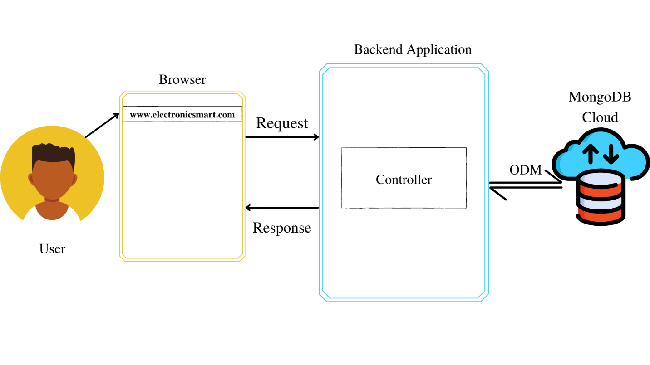

Fig. 2.1

*ODM – Object Data Manipulation

## Product Functions

* The main purpose of this project is to reduce manual work.
* Function:
* Customers can search products by category, name, ratings and price range.
* After successful login Customers can add & edit items in the cart.
* Customers can also view the status of any previous orders & cancel any order that has not been shipped yet.
* Customers can modify personal profile information (such as name, phone No., email & other details) & can enable or disable Two-Factor Authentication for additional security.
* Admins can manage products, orders and users.

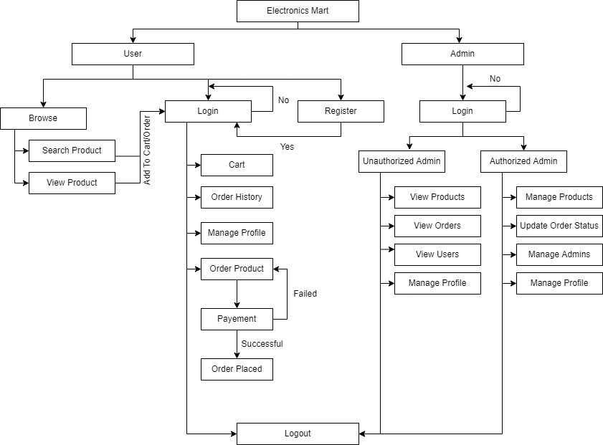

Fig. 2.2

## User Classes and Characteristics

* Customers should be able to search for products, manage cart, order products, manage their profiles.
* Admins have the following management functionalities –
* Admin – view products, users, orders
* Authorized Admins – manage products, orders, users, admins.

## Operating Environment

The product will be operating on any device which supports browser functionality.

Electronics Mart is a website and shall operate in all famous browsers, for a model we are talking about Google Chrome, Microsoft Edge, Mozilla Firefox, etc.

Hardware configuration includes the necessary requirements to run a browser application on the device.

To use the website the device should be connected to the internet.

## Design and Implementation Constraints

* The website application should be lightweight & simple API.
* The database should be able to manage a huge amount of data and should have a flexible schema with sharding (basically horizontally scalable) so the preferred database language is Mongo DB.
* Mongo Atlas should be used for storing data on the cloud has 10GB storage & 2GB RAM.
* The website should be built under Microservice Architecture.
* The programming language should support Distributed applications with many nodes, asynchronous operations (basically I/O) and good data-centric processes.
* Programming language for backend – Node JS and framework – Express JS.
* Programming language for frontend – HTML 5, CSS3, JavaScript.
* Project design should be modular with better readability.
* Communication protocols should be in XML documents encoded in UTF−8 and sent using HTTP or HTTPS.
* Security considerations are encryption of password in the database, authentication for all users & admins for accessing pages that requires identification, authorization check for admins, two-factor authentication check if enabled and secured account recovery options.
* Loading time should be minimum and for that use AWS servers for the deployment of the project for best performance. With RAM 2GB, OS Windows 8 64-bit, Hard Disk size of 10GB.
* The application should be able to run on the cross-platform so CORS should be enabled.
* Users & admins have different Front-End applications to perform actions

## User Documentation

The product will include a user manual. The manual will include a product overview, complete configuration of the software (such as Mongo DB server and other technologies used), technical details, backup procedure & contact information which will include an email address. The product will be compatible with any browser and the database will be created in Mongo DB.

## Assumptions and Dependencies

The assumptions are –

* The coding should be error-free.
* Any Front-End request should not give a Timeout error or should not have any Internal Server Error.
* The system should be user friendly so that it is easy to use for the users.
* The Electronics Mart is a 24X7 running website except for the servers where application & database are deployed & stored goes down.
* Users can access Electronics Mart from any device which supports a web browser and an internet connection.
* User & admins have their correct usernames & passwords to enter into their online accounts & do actions.

The dependencies are –

* The Servers due to which the web application will run.
* The Payment process is dependent on the payment plugin while purchasing the product.
* Based on listing requirements & specifications, the project will be developed & run.
* The admins, Client IT team should have a proper understanding of the project.
* The Information of all users must be stored in a database that is accessible by the Electronics Mart system.

# External Interface Requirements

## User Interfaces

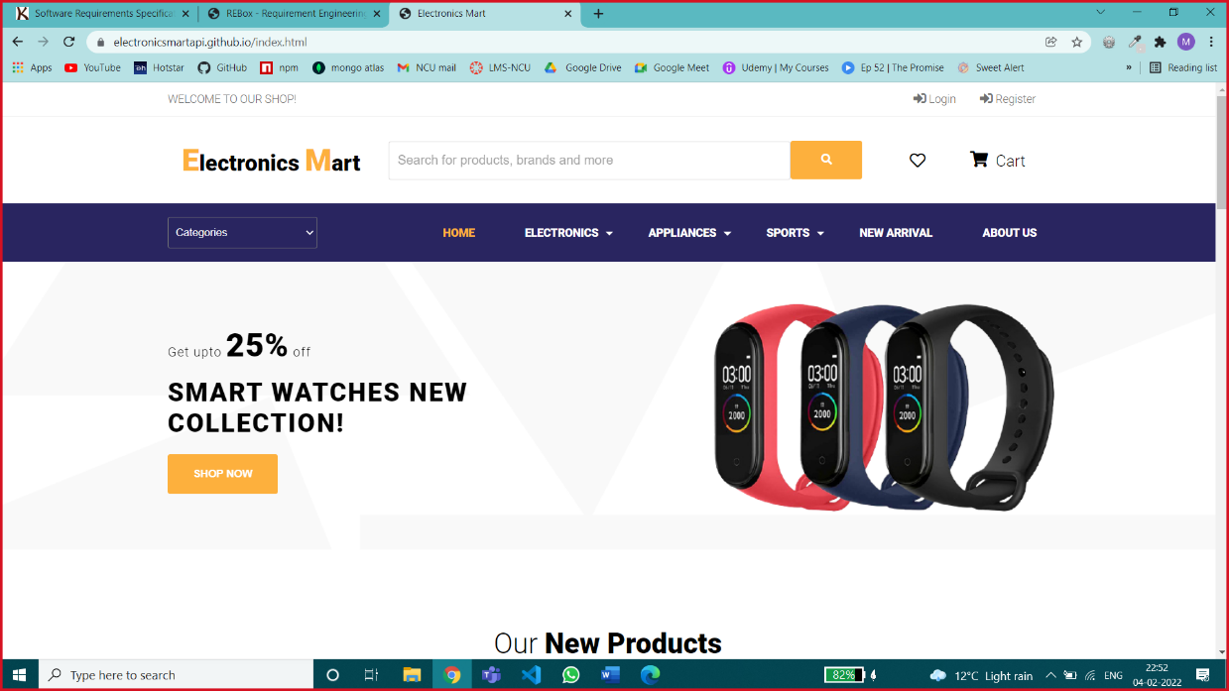

Home Page – Customers can view products on this page.

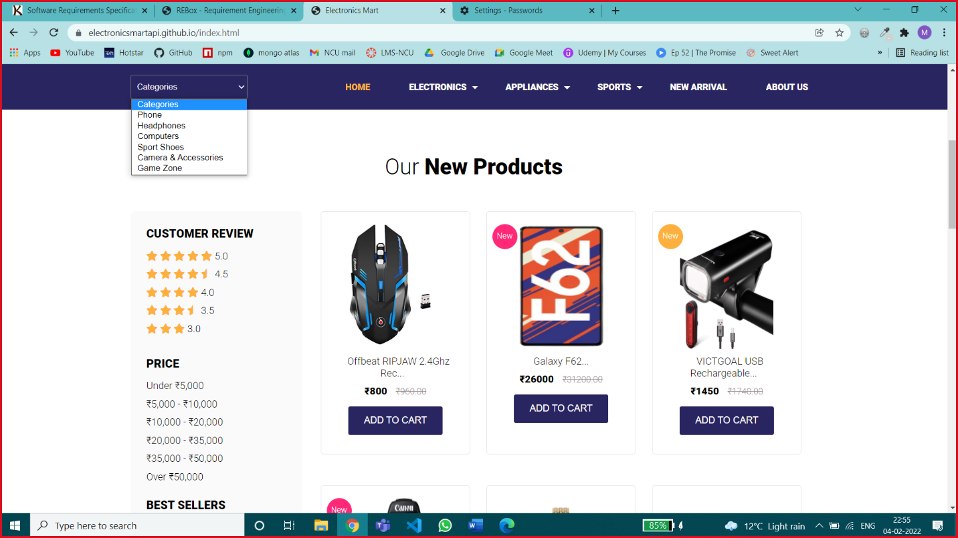

Different Options for Searching Products – Customers can search products by specific category, by Customer Review, by price range, by name.

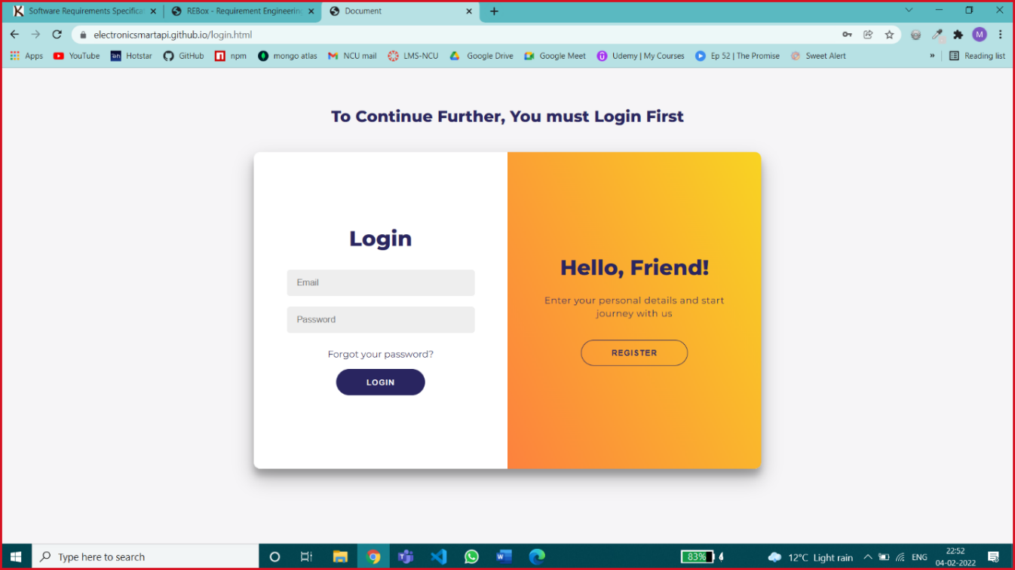

Login Page – The customer can log in with the correct E-mail Id & password or can create a new account by clicking on the register button

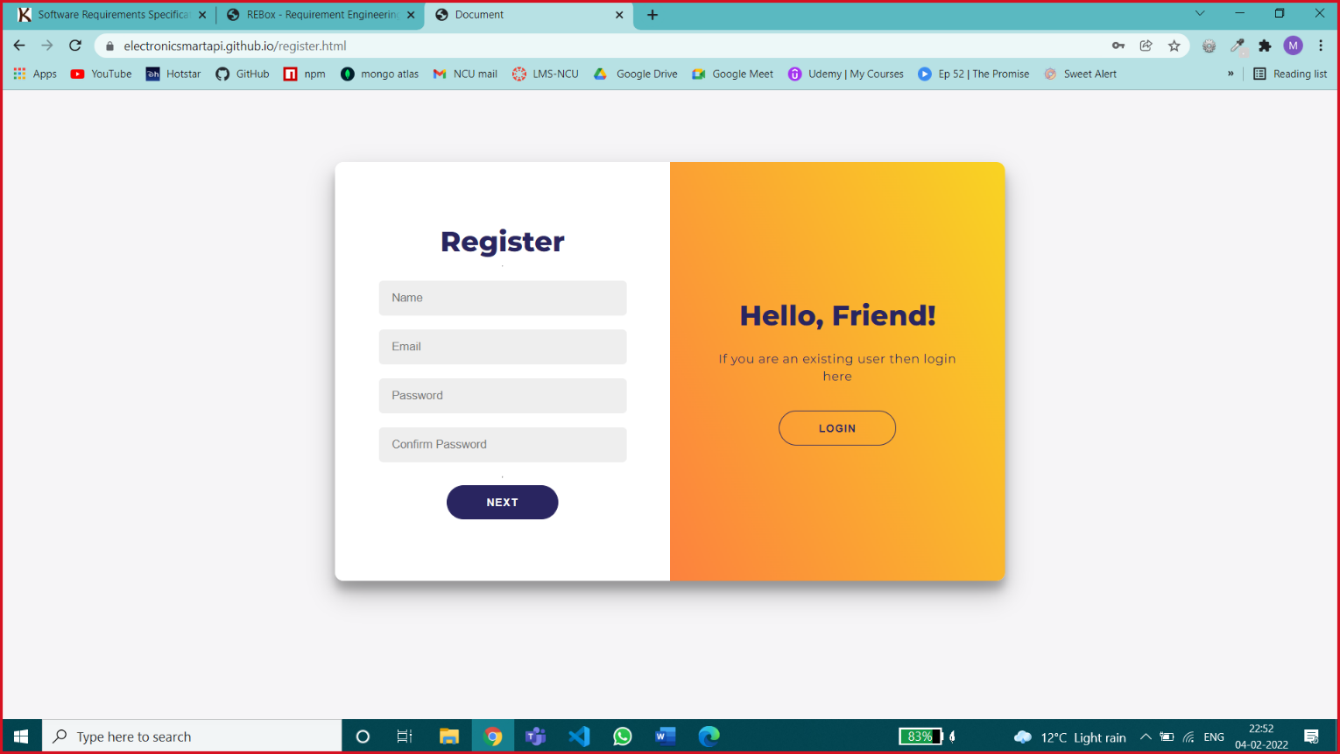

Registration Page 1 – this page is accepting all primary & sensitive information like email id & password for creating a new account, all fields are necessary.

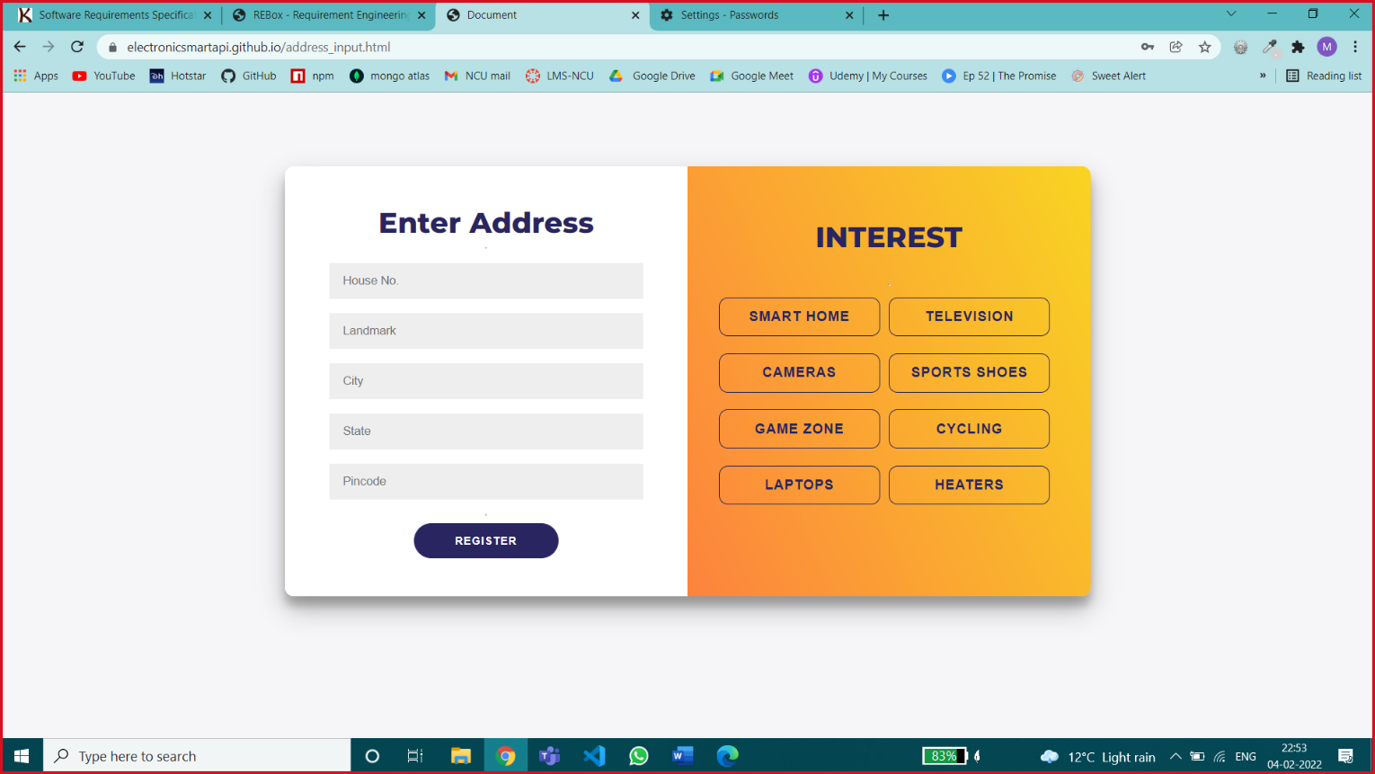

Registration Page 2 – this page is accepting customer details like address & interested category of products by selecting popular categories & address is necessary, interest is an optional field.

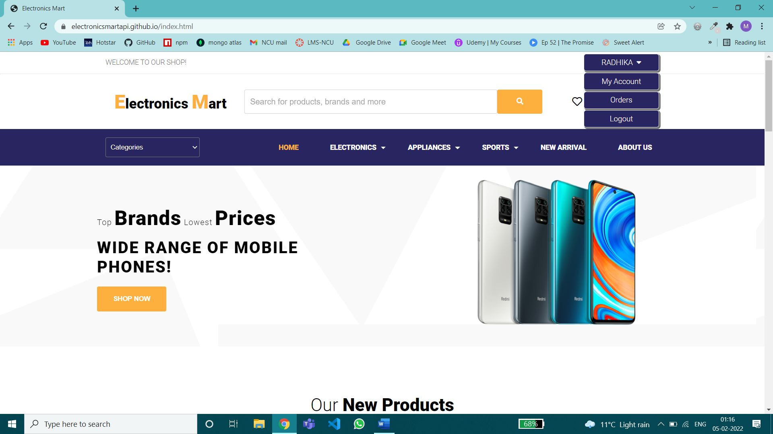

After Successful Login User will be redirected to the home page for browsing products, add products to cart, order products & will be provided my account, my orders, logout feature on the top left.

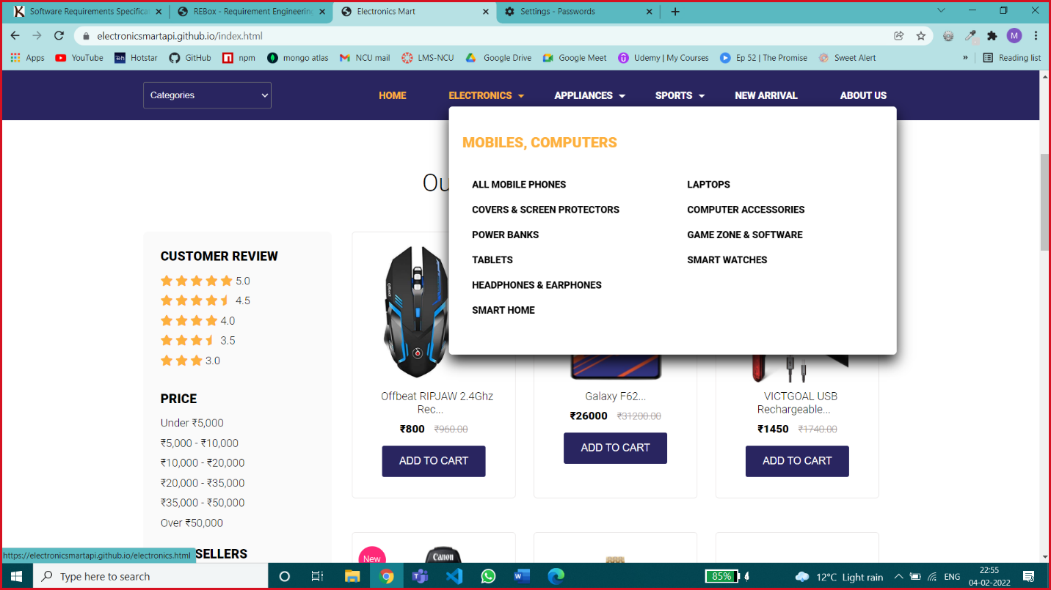

Sub-Category Dropdown Menu – In which major categories are divided into subcategories

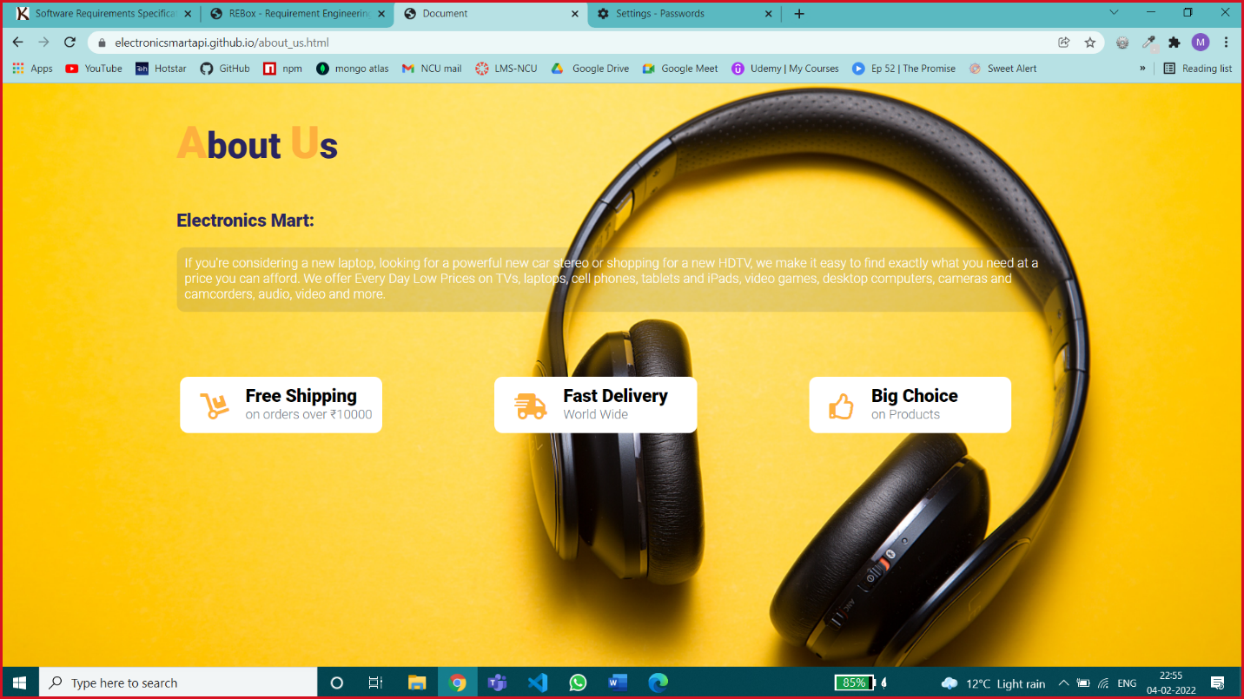

About Us Page – consist of basic information of the website

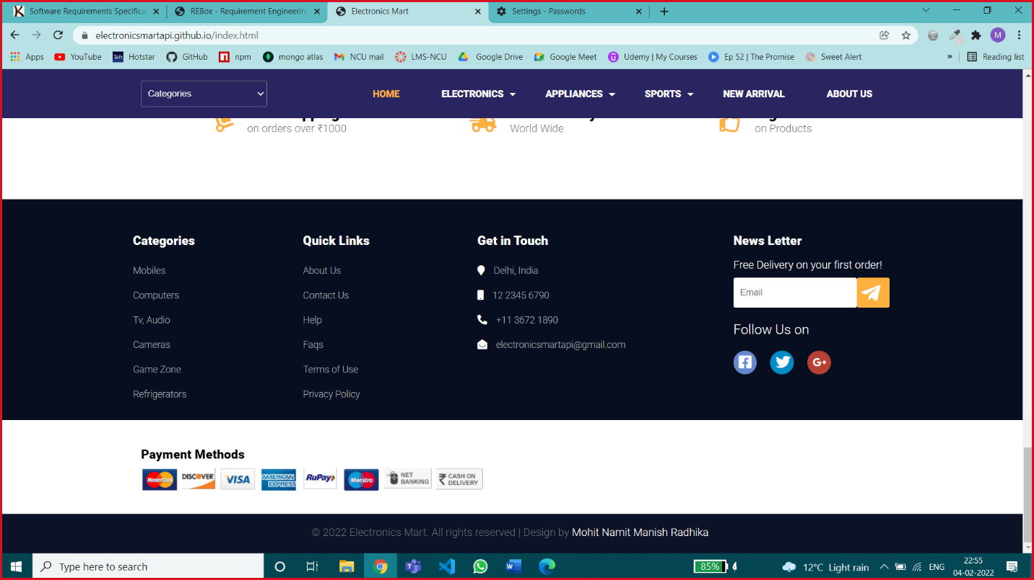

Footer of Website – News Letter service, Few other basic options.

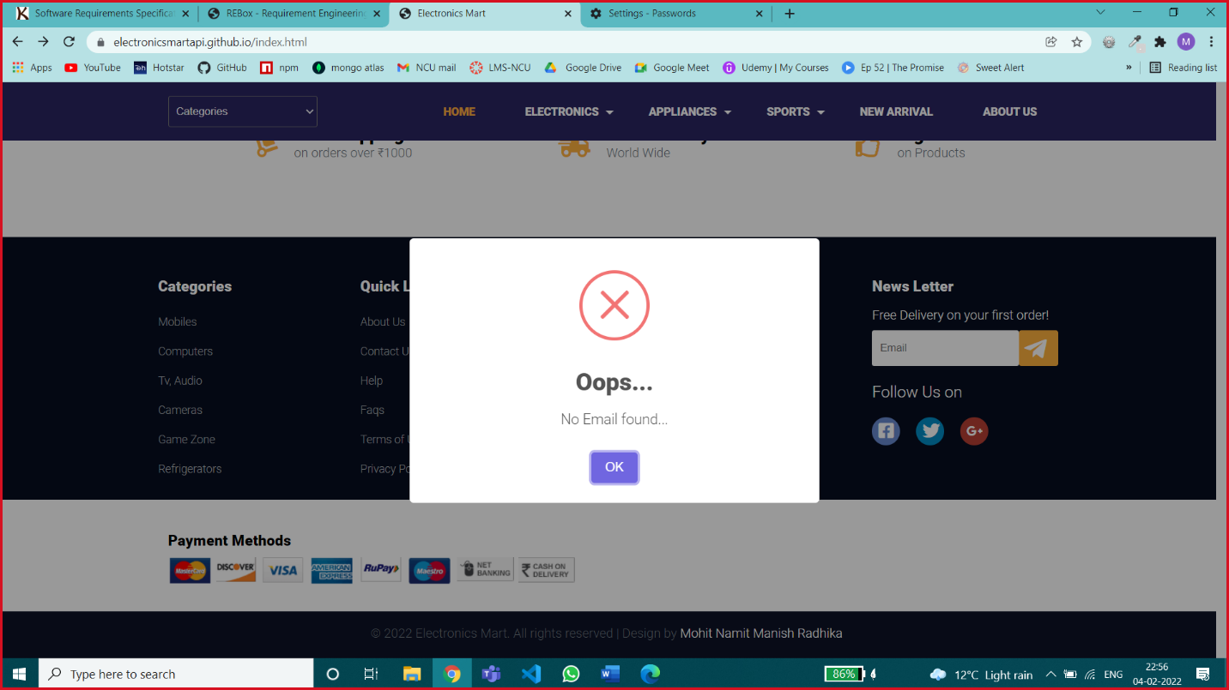

Error Message for any Invalid Input or for any Blank Input where field input is necessary.

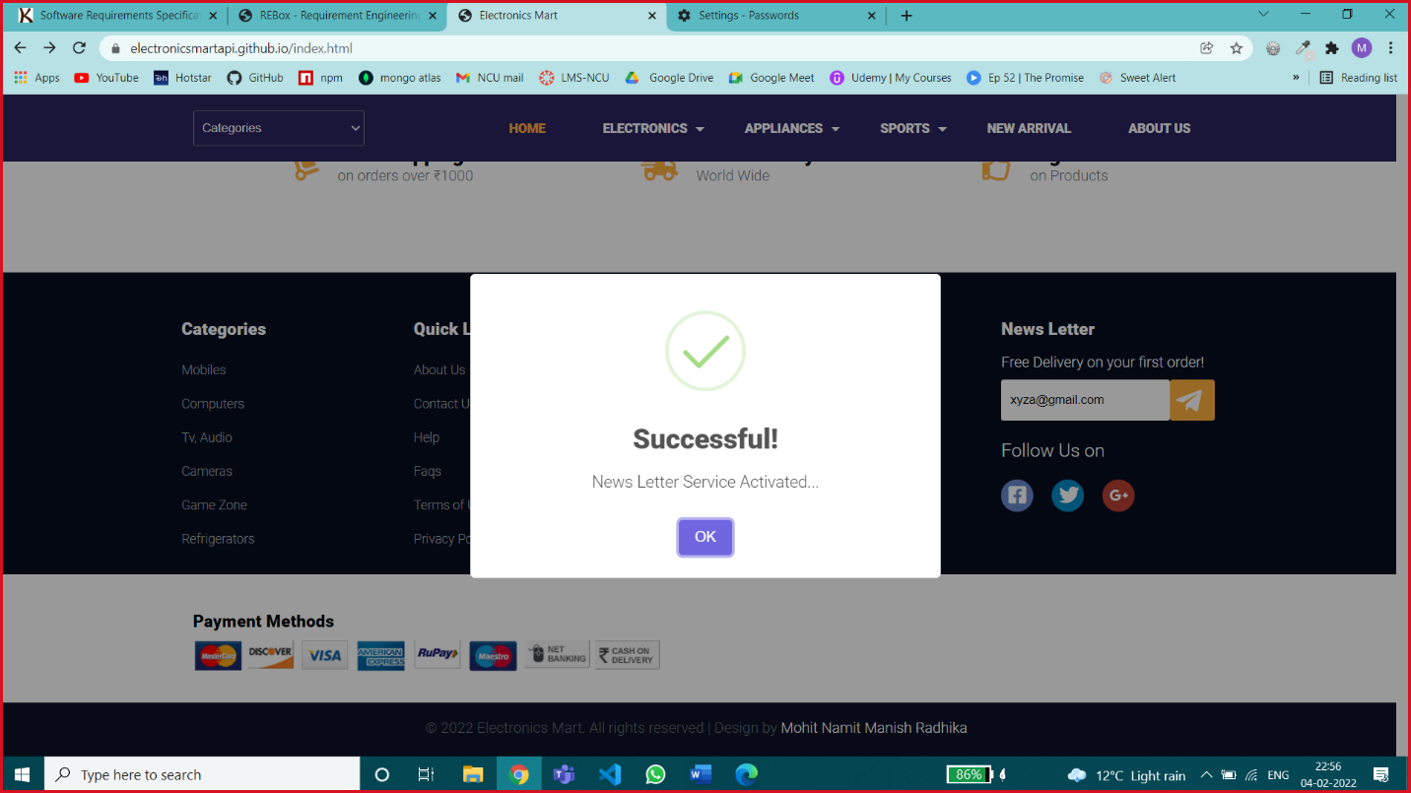

Success Message – for success Status

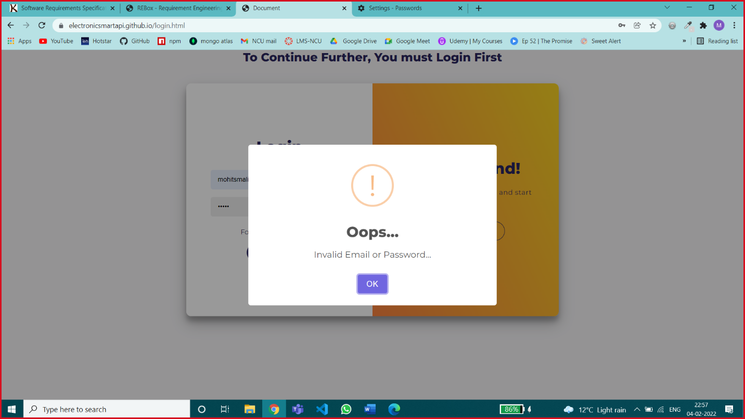

Error Message for Wrong Credentials

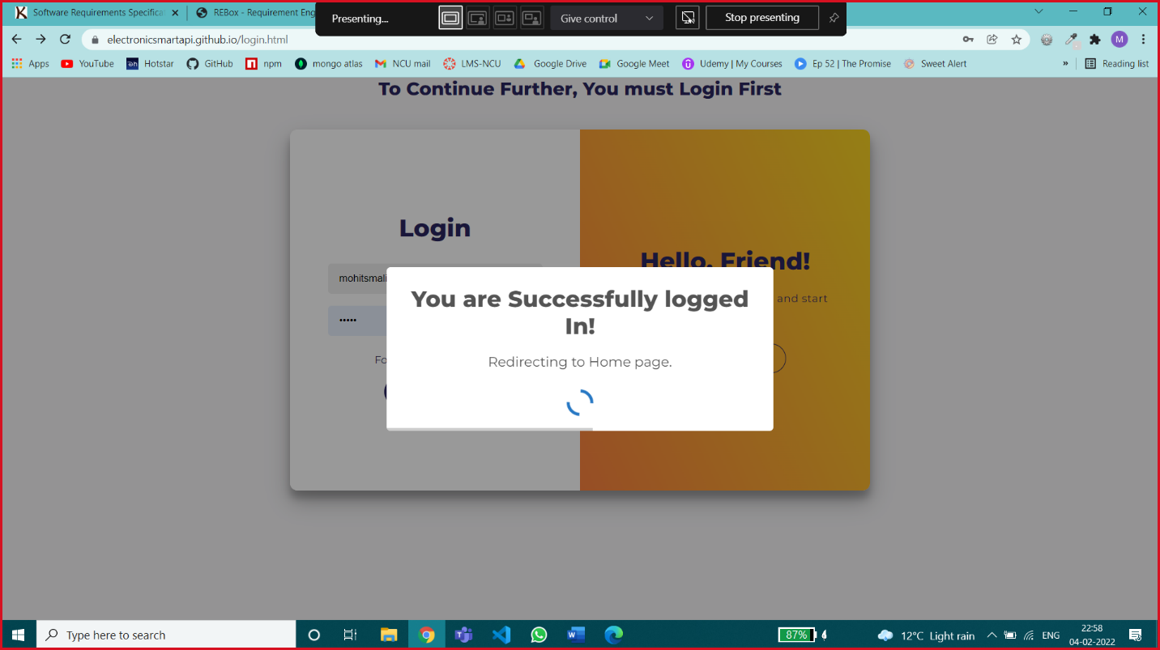

Loading Message

Screen Layouts Constraints –

Device height is not a screen layout constraint, if the height varies the content will be vertically scrollable

For particular device width ranges different website screen layouts are shown below.

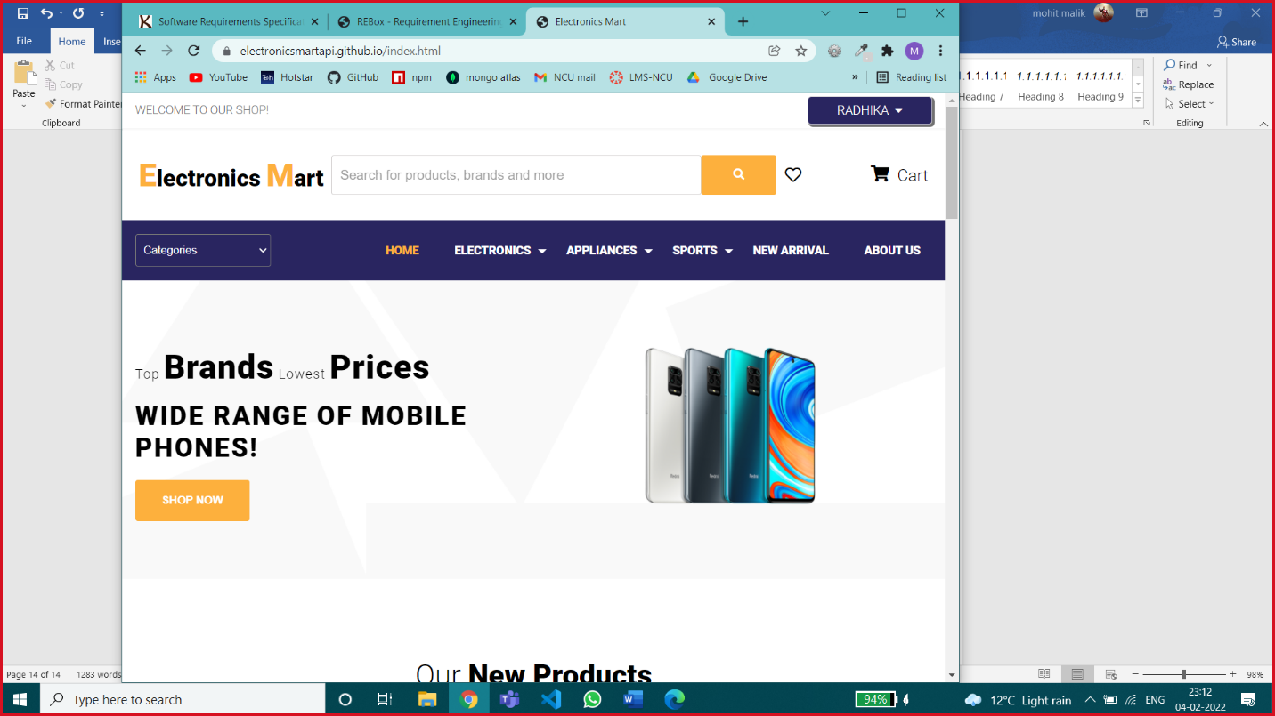

Screen width – greater than 992px

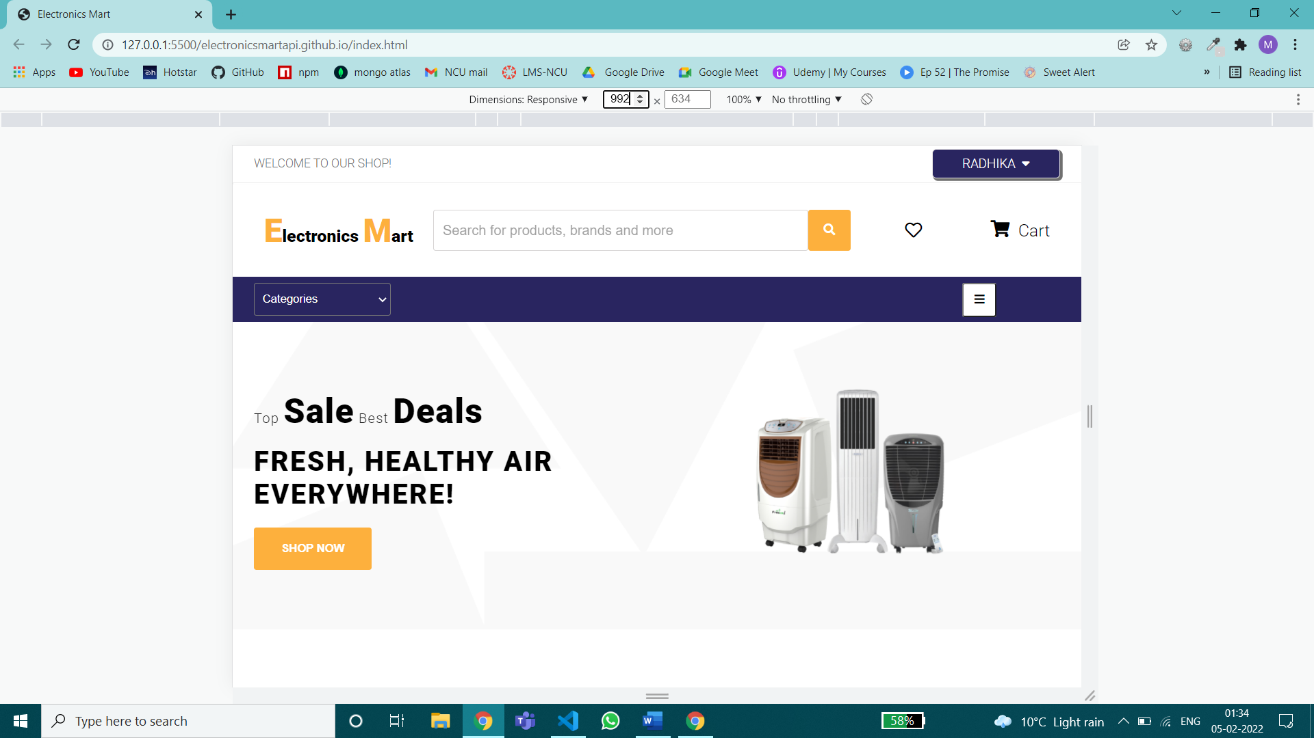

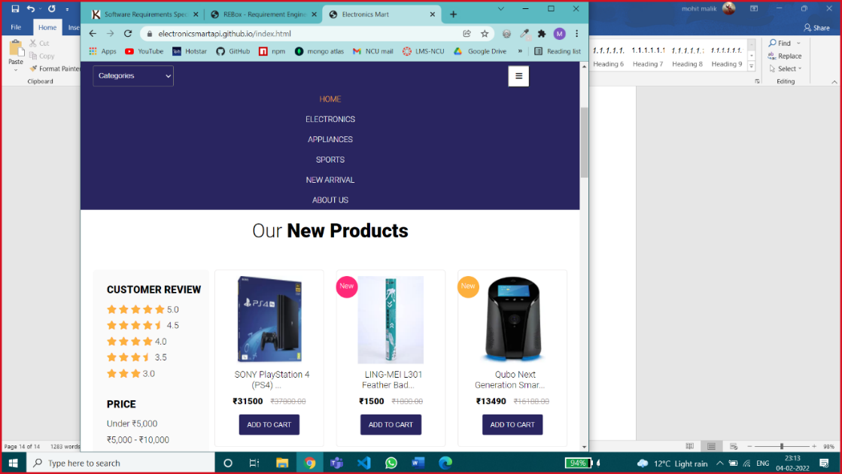

Screen Width between 992px & 768px

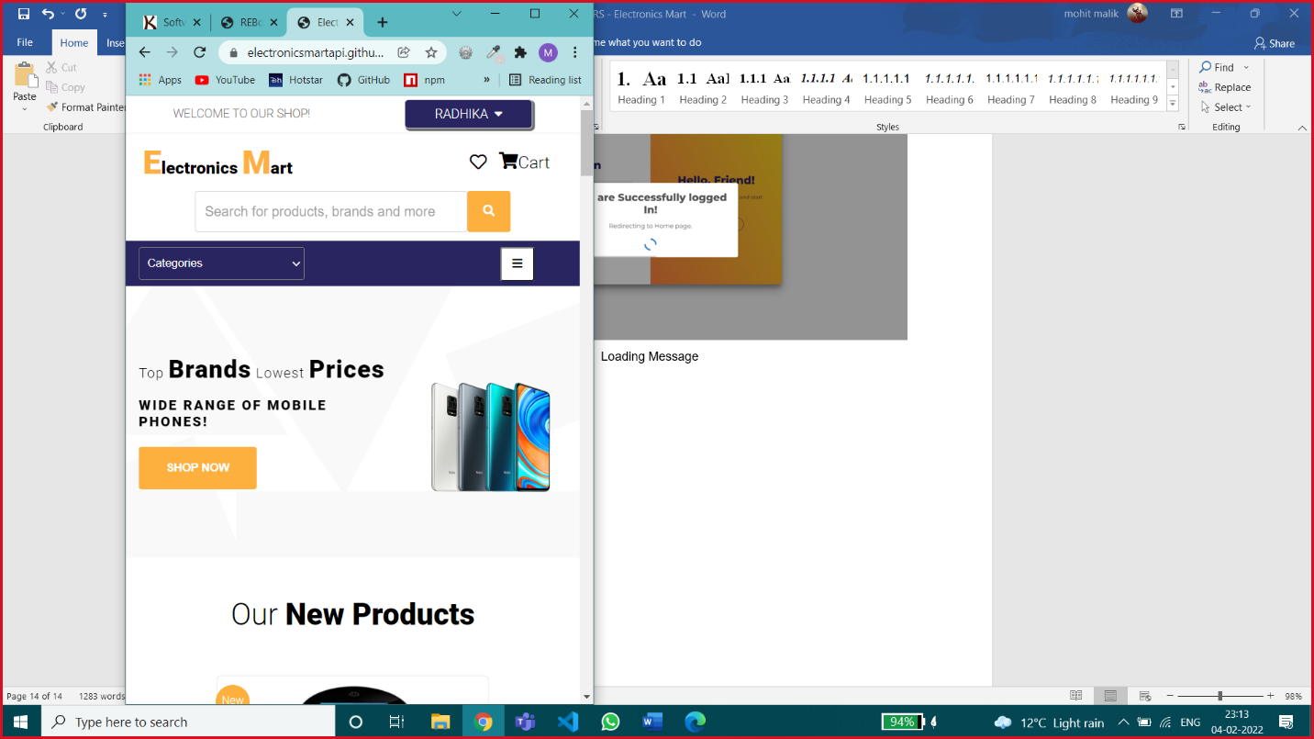 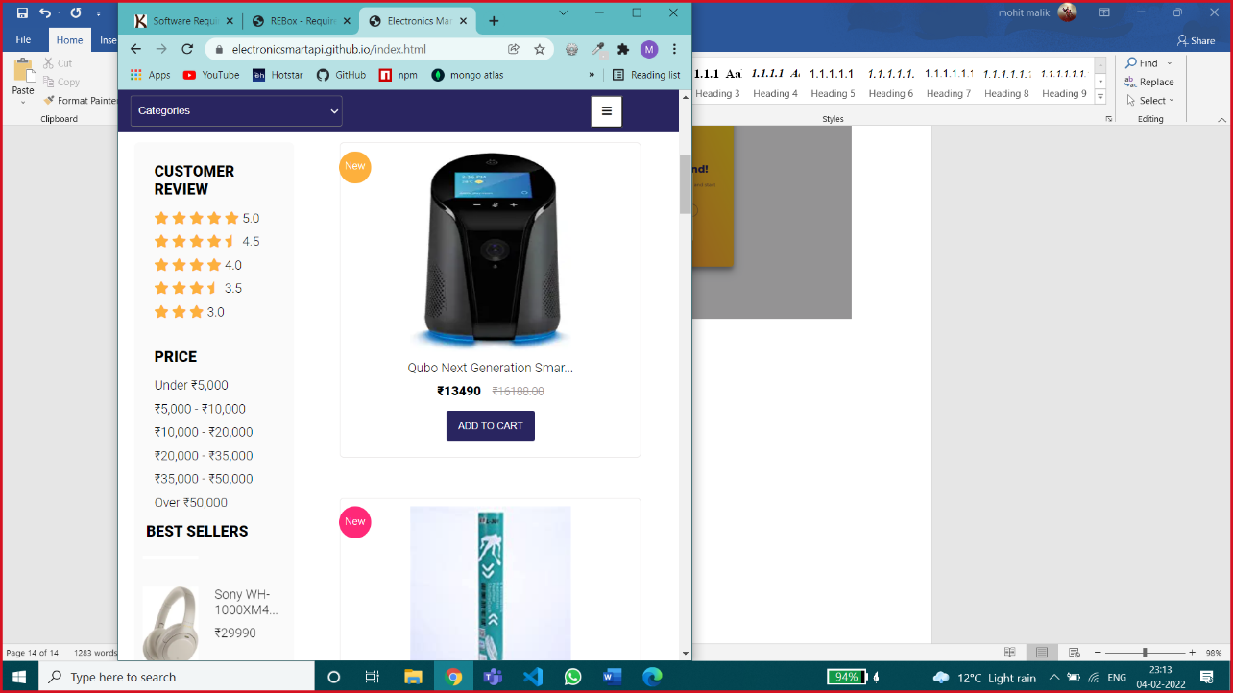

Screen width between 768px & 576px

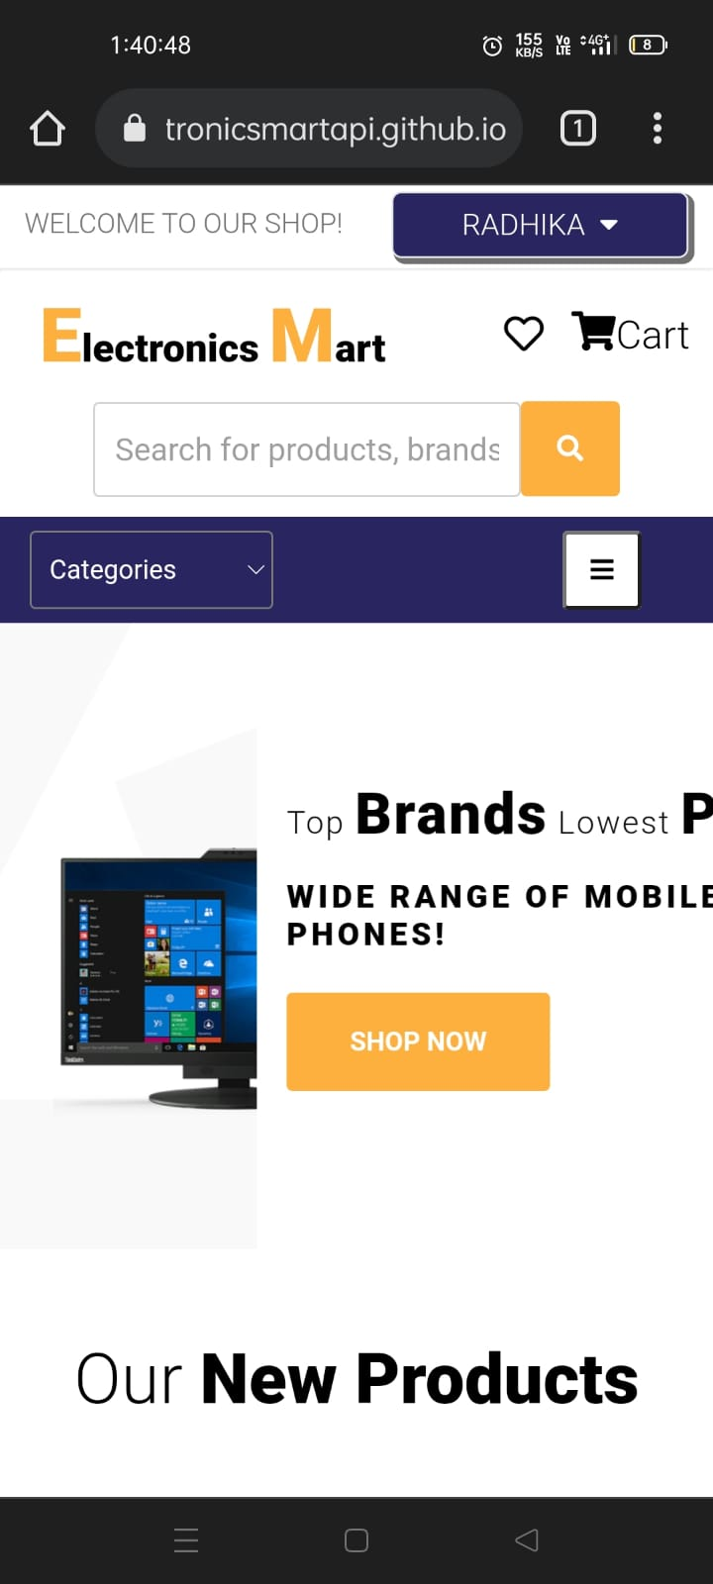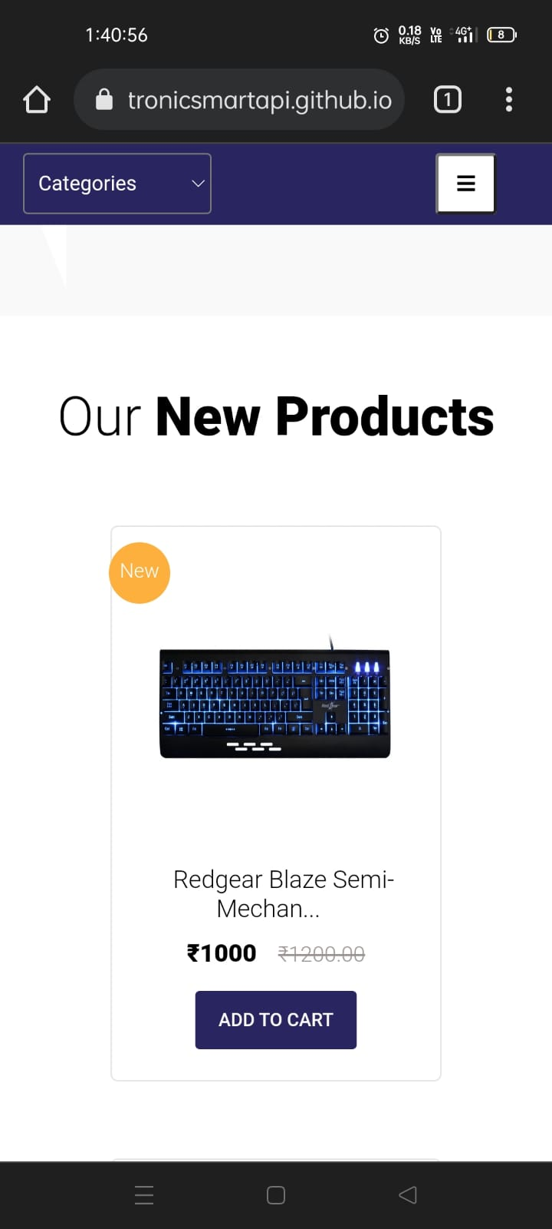

Screen width below 576px

## Hardware Interfaces

Any Hardware Device that supports the following Browsers will be able to run Electronics Mart –

Good Data is tested against and supports the following desktop browsers:

Microsoft Windows 10,8,7

* Google Chrome (the latest stable version)
* Firefox (the latest stable version)
* Microsoft Edge (latest stable version; Chromium-based only)

MacOS 10.12 and newer

* Google Chrome (the latest stable version)
* Safari (the latest stable version)
* For best results, use the latest version of Google Chrome.

Mobile Web Browser

You can view dashboards through the following mobile browser:

Android 5 and newer

* Google Chrome (the latest stable version)

iOS 10 and newer

* Google Chrome (the latest stable version)
* Safari (the latest stable version)

Browser Configuration

Any supported browser that you choose to use must meet the following requirements:

* JavaScript is enabled.
* Cookies are enabled.

## Software Interfaces

Databases – Mongo DB is managed by Mongo Atlas on the cloud.

Operating System – Windows /Mac or any other OS which can execute Node JS.

Tools – Postman for testing Backend Application, Github Desktop.

Libraries & Integrated Commercial Products – most of these are imported through NPM (Node Package Manager)

* Express JS – light-weight backend application framework.
* JWT – JSON Web Token – for generating a secure token for authentication.
* Uniquid – for generating unique Id.
* Bcrypt – For secure password encryption.
* Mongoose – for using Mongo DB queries in node js.
* Nodemailer – for sending emails to customers.
* Otp-generator – for generating otp for two factor authentication.

CORS –It is essential to enable CORS in the backend so that the frontend can request the API for sharing data. Express allows to configure and manage an HTTP server to access resources from this application.

## Communications Interfaces

Communication Standards &, network server communications protocols are HTTPS as a secure network.

Website E-mail – [electronicsmartapi@gmail.com](mailto:electronicsmartapi@gmail.com)

# System Features

## Authentication

4.1.1 Description and Priority

This feature will help company to identify user uniquely. So, this plays a crucial rule in system hence having high priority. This includes risk for a user in case of security breach like account hack or data leak, etc.

Actors for this feature –

* Users – They can use login/register
* Admins (unauthorized) – they can only use login feature, admins can’t register by themselves.
* Admins (Authorized) – they can login & after login they can register new admins.

4.1.2 Stimulus/Response Sequences

User Actions –

* Register
* Login

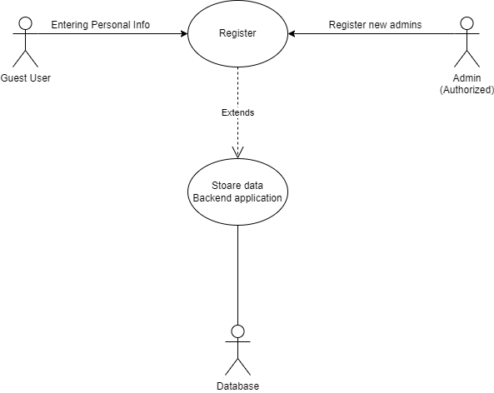

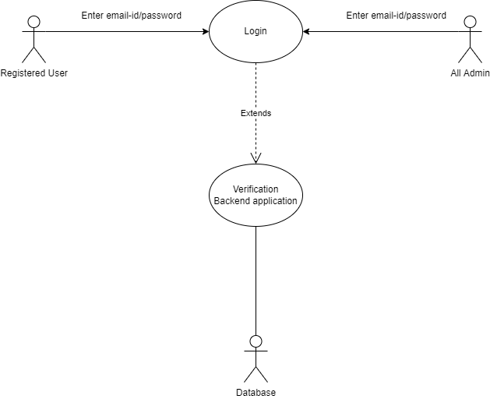

4.1.3 Functional Requirements

* Registeration: Any customer can register to Electronics Mart after filling necessary details in registration form, the email-id should be unique which means there can’t be any existing account with that email id (which is checked at the time of registration). After successful registration user should be redirected to login page, if registration is not successful user should be redirected to User authentication page having both options of login/register.

Input fields & their validation checks in registeration –

* Name
* Email-id – valid email address
* New password –
* atleast 8 letters or number
* atleast one lower case & one uppercase letter
* atleast one number & a special character
* Re-enter password – should be same as new password
* Address – House No., Landmark, City, State, Pin code (number only)
* Interested in categories – user can choose his/her interested categories of products from most popular categories, this is an optional input.

Register might fail in these cases – duplicate email-id, weak password (should pass password validation check), both passwords should match (new pass & re-enter new pass), if any necessary filed is empty last & least possible in case server is down then user will get an error message corresponding to particular error.

After successful registeration user will receive an email containing a unique account activation link, after successful activation of account user can login with his user id & password.

* Login: On login page any user has to enter correct email-id & password, then that email is checked in database if it’s existing then password that user entered is verified with the password in database. If its correct then login is successful & user is redirected to home page of web site where user has multiple functionalities as mentioned in next points.

Login might fail in these cases – If he has entered wrong email-id, wrong password it shows a message saying ‘Invalid Id or Password’ or if user leaves a field, a dialog box shows a warning that a field is empty.

On any new device login, user will get an email regarding security of his account.

If user has enabled Two factor Authentication, then after entering correct email-id & pass then user will be redirected to check OTP page, OTP main will be sent via email on user mail-id, after entering correct otp user can access his account.

User can use forgot password option in case he/she is not able to login due to password issues.

User will have 2 options for recover account –

Recover by email – user will get a recovery email & then user can enter new password with same password validation check as mentioned at the time of registeration.

Recover by old password – if user don’t know current password, then he/she can recover account by previous password & can set new password with same password validation check as mentioned at the time of registeration.

Email regarding successful account recover & new password will be sent to user’s email.

4.1.4 Modules used –

|  |  |  |
| --- | --- | --- |
| 6.1.1 Check Email | 6.1.2 Register | 6.1.3 Activate Account |
| 6.1.4 Login | 6.1.5 Check OTP | 6.1.6 Forgot Password |
| 6.1.7 Account Recovery by Email | 6.1.8 Account Recovery by Old Password | 6.6.5 Encrypt |
| 6.6.6 Node Mailer | 6.6.7 Generate Token | 6.6.11 Generate Key |
| 6.6.12 Verify Key | 6.6.13 Get Doc |  |

## Browse & Search Products

4.2.1 Description and Priority

This is one of the most important features of the website which enables the customer to browse products in an optimized way, hence having high priority. User can search products by applying many filters and combinations of different filters too.

Actors for this feature –

* All Users
* All Admins

4.2.2 Stimulus/Response Sequences

User Action –

* View all products
* View by major categories (like Electronics – phone, laptop, earphones, etc.)
* View by categories
* View by price range
* View by customer ratings
* View new arrivals
* Search products by name
* View by categories & customer ratings (combination of 2 filters)
* Search products by name in specific category (combination of 2 filters)
* View by rating & categories (combination of 2 filters)
* View by price range & categories (combination of 2 filters)
* View by interest (only for registered users if they have selected any interested category while registration process)
* View specific product with its details.

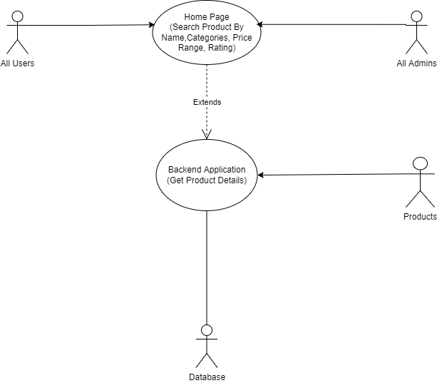

4.2.3 Functional Requirements

* View all products – users can see all products with mix categories & mix price range
* View by major categories – Products can be sorted via 3 major categories Electronics, Appliances and Sports.

These major categories include these products –

Electronics – Mobile phones, cover & screen protectors, power banks, tablets, headphones & earphones, smart home, laptops, computer accessories, game zone & software, smartwatches

Appliances – TV, speakers, camera & DSLR, gaming consoles, AC, heaters, refrigerator, washing machine

Sports – cricket, badminton, cycling, football, gym equipment, sport shoes,

* View by categories – Users can select a specific category from the categories dropdown and view products.
* View by price range – Users can also browse products in between or less than specific price ranges.

Price ranges –

* Under ₹5,000
* ₹5,000 - ₹10,000
* ₹10,000 - ₹20,000
* ₹20,000 - ₹35,000
* ₹35,000 - ₹50,000
* Over ₹50,000
* View by customer ratings – Users can view products based on ratings as well.

Ratings - 5, 4.5, 4, 3.5, 3 stars, on selecting any of these ratings, the products having more than or equal to that rating will be displayed.

* View new arrivals – Products can also be browsed by new launched/arrived products, basically those products which were last stored in the data base.
* Search products by name – A particular product can also be viewed by searching.

If that specific product is not present in the database, then the products related or having similar name will be displayed otherwise there will be no change in products.

* View by categories & customer rating – 2 filter of category & price range are applied together for better product searching.
* Search products by name in specific category – user can search products by name in a specific category.
* View by rating & categories – user can browse products by rating in a category or major category.
* View by price range & categories – user can browse products by price range in major categories (Electronics, appliances, sports).
* View by interest – users can see products by their interested category, this option is only available to registered users. Products will be show on the basis of the interested category they selected at the time of registeration, if they selected none then no change in products.
* View specific product with its details – users can view detailed view of a specific product like -
* Product description
* customer rating & reviews
* can search specific keywords in reviews
* If product’s quantity is less than 10 in stock then it’s also displayed or if it’s out of stock

*Only 9 products will be shown on one screen. for view more user have to go to next page.

4.2.4 Modules used –

|  |  |  |
| --- | --- | --- |
| 6.2.2 View all Products | 6.2.3 View by Interest | 6.2.4 View by name |
| 6.2.5 View by Single Category | 6.2.6 View by multiple categories | 6.2.7 View by price |
| 6.2.8 View by rating | 6.2.9 Search by name in category | 6.2.12 View by product id |
| 6.2.11 View by price in categories | 6.6.13 Get Doc | 6.6.1 Authentication |
| 6.6.2 Two factor Auth | 6.2.10 Search by name in multiple categories |  |

## Order Products

4.3.1 Description and Priority

This feature will help logged in users to order any product in stock. This feature is using

an external plugin dependency for payment. After successful payment the product is

ordered. This is one of the key features of shopping website & involves payments due to

which its having high priority & risk.

Actors for this feature –

* Registered User
* Unauthorized Admins
* Authorized Admins

4.3.2 Stimulus/Response Sequences

User Action – Order products, cancel or return products & view previous orders.

Unauthorized Admins – can view all orders

Authorized Admins – can view all orders & update order status

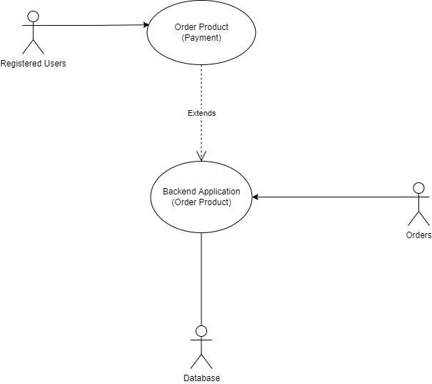

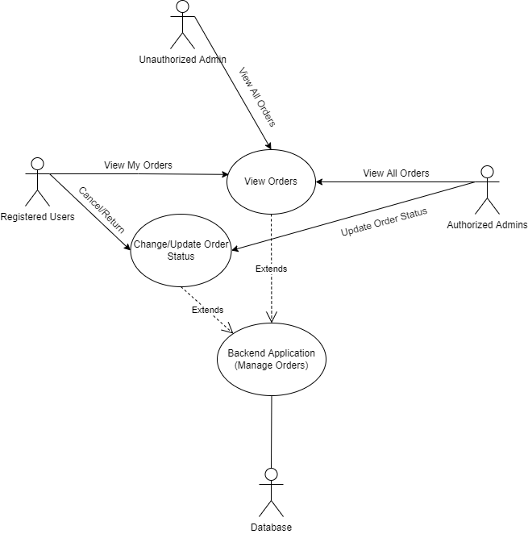

4.3.3 Functional Requirements

* Order Products – The user can order any product in stock after successful payment, payment

Implemented by an external plugin.

User will get an email after successful order, which includes the order Id.

* Cancel/return Order – user can cancel any order or return it after mentioning a valid reason, in case he has returned the quantity of the product will be restored & updated in

Database. In case of return it should be sent to different department.

* View my orders – a user can also see his previous orders.
* View all orders – all admins can view all orders in optimized way.
* View orders of a single users – enter user id
* View orders by their status – choose an order status
* View order of a particular product – enter product id

*Only 9 orders will be visible on screen at once, for view more user have to go to next page.

* Update Order Status – authorized admins can update order status on completion of different stages of Order.

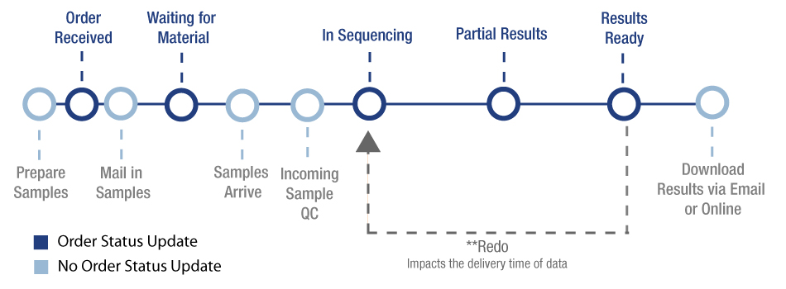

Pending — Customer started the checkout process but did not complete it. Incomplete orders are assigned a "Pending" status and can be found under the More tab in the View Orders screen.

Awaiting Payment — Customer has completed the checkout process, but payment has yet to be confirmed. Authorize only transactions that are not yet captured have this status.

Awaiting Fulfillment — Customer has completed the checkout process and payment has been confirmed.

Awaiting Shipment — Order has been pulled and packaged and is awaiting collection from a shipping provider.

Awaiting Pickup — Order has been packaged and is awaiting customer pickup from a seller-specified location.

Partially Shipped — Only some items in the order have been shipped.

Completed — Order has been shipped/picked up, and receipt is confirmed; client has paid for their digital product, and their file(s) are available for download.

Shipped — Order has been shipped, but receipt has not been confirmed; seller has used the Ship Items action. A listing of all orders with a "Shipped" status can be found under the More tab of the View Orders screen.

Cancelled — User can cancel the order until it’s out for delivery or Seller can cancel an order, due to a stock inconsistency or other reasons. Stock levels will automatically update depending on your Inventory Settings. Cancelling an order will not refund the order. This status is triggered automatically when an order using an authorize-only payment gateway is voided in the control panel before capturing payment.

Returned — Seller has used the Refund action to refund the whole order. A listing of all orders with a "Refunded" status can be found under the More tab of the View Orders screen.

4.3.4 Modules used –

|  |  |  |
| --- | --- | --- |
| 6.3.1 Order Product | 6.3.2 View one order (By user) | 6.3.3 View orders (By user) |
| 6.3.4 Change order status (By User) | 6.3.5 View all orders (By admin) | 6.3.6 View order by user |
| 6.3.7 View order by product id | 6.3.8 View single order | 6.3.9 Search order by order status |
| 6.3.10 Update order status | 6.6.1 Authentication | 6.6.2 Two factor Auth |
| 6.6.4 Authorized Admin Auth | 6.6.3 Admin Authentication | 6.6.6 Node Mailer |
| 6.6.13 Get Doc |  |  |

## Manage My Account

4.4.1 Description and Priority

This feature will allow logged in user to view, update, delete account. This includes user data so this is a medium priority feature. Risk regarding data leak or hacking of account should be handled properly for security.

Actors for this feature –

* Registered users
* All admins

4.4.2 Stimulus/Response Sequences

* View my account
* Update account details like –
* Name
* Email id
* Password
* address
* Enable/disable two factor authentication
* Delete account

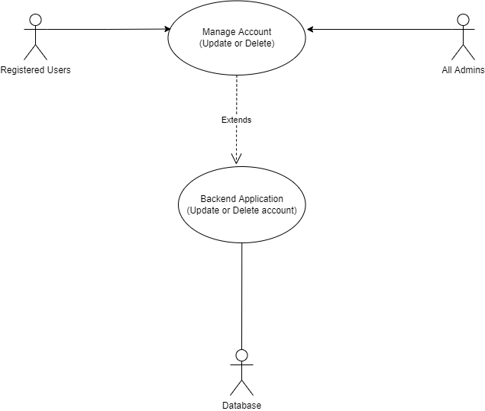

4.4.3 Functional Requirements

* View my account – user can view his/her account details i.e., name, email-id, address, two factor authentication enabled or disabled.
* Update account details –
* Name – user can change his/her name
* Email id – user can change his/her email id, the new email id should not be registered to any other Electronics Mart account & should be a valid email id.

Email will be sent to the new email id for successful update.

* Password – user has to enter the old password of account in order to change password, the new password validation is same as password validation at the time of registeration.

Email will be sent to the user’s email id about change of password, for security in case the real owner hasn’t updated the password then he/she should recover account as soon as possible.

* Address – user can update address, user can change whole address or any single attribute of address on his/her choice.
* Enable/disable two factor authentication - user can enable of disable this extra account security feature, in this if user logins then a 6-digit OTP will be sent to user’s email id and he/she has to enter that OTP at the time of login.

An email will be sent to the user’s email id about enabling or disabling Two-factor authentication.

* Delete account – user can delete his/her account any time they want, at the time of deletion they have to enter the correct password of their account for verification.

An email will be sent to the user’s email id about the deletion of the account.

The user data will be stored in another collection for one year.

4.4.4 Modules used –

|  |  |  |
| --- | --- | --- |
| 6.1.9 View my account | 6.1.10 Activate 2 factor Auth | 6.1.11 Deactivate 2 factor Auth |
| 6.1.12 Update Name | 6.1.13 Update Email | 6.1.14 Update Password |
| 6.1.15 Update Address | 6.1.16 Delete user/Admin | 6.6.1 Authentication |
| 6.6.2 Two factor Auth | 6.6.4 Authorized Admin Auth | 6.6.3 Admin Authentication |
| 6.6.6 Node Mailer | 6.6.5 Encryption | 6.6.7 Generate token |
| 6.6.13 Get Doc |  |  |

## Manage My Cart

4.5.1 Description and Priority

This feature will allow logged-in users to add, delete items in the cart. Users can directly place an order

From my cart, if that product is in stock. This is an additional feature so it’s having low

Priority.

The actor for this feature is only a registered user.

4.5.2 Stimulus/Response Sequences

* Add items to the cart
* View my cart
* Update items in the cart
* Delete items in the cart
* Place order

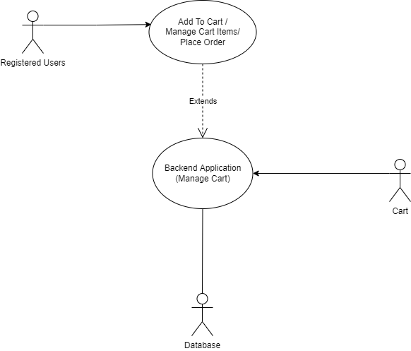

4.5.3 Functional Requirements

* Add items to cart – user can add any product to the cart, initially, quantity of products in cart is one.
* View my cart- user can view items added to the cart, only 9 items will be shown on a page, for more user has to go to the next page.
* Update items – user can increase or decrease the quantity of items in the cart.
* Delete items in the cart –
* Delete one item – user can delete any single item in the cart.
* Delete all items – user can delete all items in the cart, basically user’s cart will be emptied.
* Place order –
* Order one item – user can order any single item in the cart if that item is in stock.
* Order all items – user can also order all items in the cart, but if any item is out of stock, then the user has to order other items one by one.

4.5.4 Modules used –

|  |  |  |
| --- | --- | --- |
| 6.4.1 Add to cart | 6.4.2 View my cart | 6.4.3 View one cart item |
| 6.4.4 Search in cart | 6.4.5 Delete cart item | 6.4.6 Delete user cart |
| 6.6.1 Authentication | 6.6.2 Two factor Auth | 6.6.13 Get Doc |
| 6.4.7 Update user cart |  |  |

## Manage Products

4.6.1 Description and Priority

This feature will allow logged-in admins can add, update, delete products after successful login.

This will provide an Interface to manage products so this is a low priority feature.

Actors for this feature – Authorized admins

4.6.2 Stimulus/Response Sequences

* Add product
* Update product
* Delete product

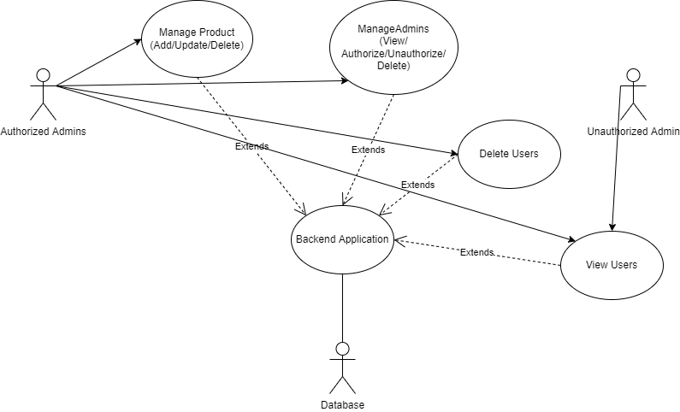

4.6.3 Functional Requirements

* Add Product – Admins can add a single product at a time.

Input fields & their validation checks –

* Product name
* Product description
* Product Image link – should be a valid image link
* Product price – should be greater than or equal to 0
* Product Quantity – should be greater than or equal to 0
* Product Category

If any of the fields is left empty product can’t be added.

* Update Product – Admins can update different attributes of a product
* Update product name, price, description, image, category with the same validation checks which were used at the time of adding product
* Update product quantity – admins may update quantity more often than product’s other attributes so update quantity is separated from update of other attributes of products, Admins have to enter the change in product quantity and the total quantity of product should be greater than or equal to zero otherwise update will be unsuccessful.
* Delete product – admins can delete any product from the database if required.

4.6.4 Modules used –

|  |  |  |
| --- | --- | --- |
| 6.2.1 Add Product | 6.2.17 Update product | 6.2.18 Update quantity |
| 6.2.19 Delete product | 6.6.1 Authentication | 6.6.2 Two factor Auth |
| 6.6.4 Authorized Admin Auth | 6.6.3 Admin Authentication |  |

## Manage Admins

4.7.1 Description and Priority

This feature will allow logged in authorized admins to view admins, authorize/unauthorize admins / delete admins. This feature is having high priority because there's a risk of administration power.

Actor for this feature - Authorized admins

4.7.2 Stimulus/Response Sequences

* View admins
* Authorize/Unauthorize admins
* Delete admins



4.7.3 Functional Requirements

* view admins - admin can view all admins, for optimized search admin can search admins by -
* Search by admin id
* Search by email
* Search by name
* View a specific admin - complete details of the admin will be shown

*Only 9 orders will be visible on-screen at once, to view more users have to go to the next page.

* authorize/unauthorize admins - admins can Authorize or unauthorize other admin as per requirements, option for authorizing or unauthorizing other admins will be provided in the detailed view of that admin

An email will be sent to that admin's email id who is authorized or unauthorized.

* delete admin - admin can delete any admin as per requirements, this feature is also provided in the detailed view of that admin.

An email will be sent to that admin's email id that his account has been deleted if it looks wrong, he/she can contact the administration.

4.7.4 Modules used –

|  |  |  |
| --- | --- | --- |
| 6.1.17 View all users/Admins | 6.1.18 View by user-id/ admin id | 6.1.19 View by email id |
| 6.1.20 View by name | 6.1.25 Authorize Admin | 6.1.26 Unauthorized Admin |
| 6.6.1 Authentication | 6.6.2 Two factor Auth | 6.6.4 Authorized Admin Auth |
| 6.6.3 Admin Authentication | 6.6.6 Node Mailer | 6.6.13 Get Doc |
| 6.1.24 Delete users/admin |  |  |

## Manage Users

4.8.1 Description and Priority

This feature will allow logged-in admins to view & search users in an optimized way & delete any user if required. This feature is helping admins to manage users so it is a medium priority Feature.

Actors for this feature

* Unauthorized admins - can view & search any user.
* Authorized admins - can view & search any user and delete.

4.8.2 Stimulus/Response Sequences

* + View users
  + Delete users



4.8.3 Functional Requirements

* View users - admins can view or search users in an optimized way
* View all users
* View by name
* View by email id
* View by user-id
* View by city
* View by state
* View by pin code

*Only 9 users will be visible on-the screen at once, to view more users have to go to the next page.

* Delete users – only authorized admins can perform this action, if any user is violating any T&C, then his/her account can be deleted.

An email will be sent to the user’s email id that his account has been deleted if it looks wrong, he/she can contact the administration.

4.8.4 Modules used –

|  |  |  |
| --- | --- | --- |
| 6.1.17 View all users/Admins | 6.1.18 View by user-id/ admin id | 6.1.19 View by email id |
| 6.1.20 View by name | 6.1.21 View by pin code | 6.1.22 View by city |
| 6.1.23 View by state | 6.1.24 Delete users/admin | 6.6.13 Get Doc |
| 6.6.1 Authentication | 6.6.2 Two factor Auth | 6.6.4 Authorized Admin Auth |
| 6.6.3 Admin Authentication | 6.6.6 Node Mailer |  |

## Rate & Review products

4.9.1 Description and Priority

This feature will allow logged users to rate & review products so that they can share their experiences of using products with other buyers. This feature helps other users to select better products so, this is feature is having low priority. Any user can only rate or review a product when he/she has ordered that product & order status is delivered. Otherwise, the use user can’t rate or review it.

Actor for this feature – Registered user

4.9.2 Stimulus/Response Sequences

* Rate product
* Edit rate
* Review product
* Edit review

4.9.3 Functional Requirements

* Rate Product – The user can rate the product once the product is delivered to him/her, rate the product from 1.0 to 5.0 where higher rating means a good product.
* Edit rating – The user can edit the rating of the product he/she has given earlier.
* Review product – user can review the product once the product is delivered to him/her, in review user can share his/her experience in a paragraph with a word limit of 200 words.
* Edit review – The user can edit the review of the product he/she has given earlier.

4.9.4 Modules used –

|  |  |  |
| --- | --- | --- |
| 6.2.13 Rate product | 6.2.14 Edit rating | 6.2.15 Review Product |
| 6.2.16 Edit review | 6.6.1 Authentication | 6.6.2 Two factor Auth |
| 6.6.13 Get Doc |  |  |

## News Letter service

4.10.1 Description and Priority

This feature will allow users to receive newsletter emails from the website & logged in admins to send newsletter emails & view previous newsletter emails. This is an additional feature of the website so it’s having low priority.

Actors of this feature –

* All users
* All admins

4.10.2 Stimulus/Response Sequences

* Activate newsletter service
* Send newsletter
* View previous newsletters

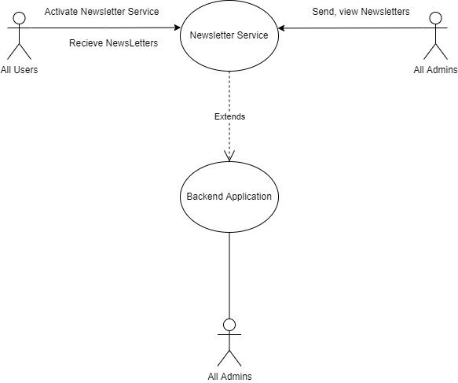

4.10.3 Functional Requirements

* Activate newsletter Service – any user can activate newsletter service by entering their correct email address in the newsletter section of the website, already registered users need not activate this service because they will receive all newsletters regarding exiting deals & sales.
* Send newsletter – any admin can send a newsletter which requires a subject & body.
* View newsletter – any admin can view the previous newsletter, the subject, body, receiver’s list of the newsletter.

4.10.4 Modules used –

|  |  |  |
| --- | --- | --- |
| 6.5.1 Activate newsletter service | 6.5.2 Send newsletter | 6.5.3 View newsletter |
| 6.6.1 Authentication | 6.6.2 Two factor Auth | 6.6.4 Authorized Admin Auth |
| 6.6.3 Admin Authentication | 6.6.6 Node Mailer | 6.6.13 Get Doc |

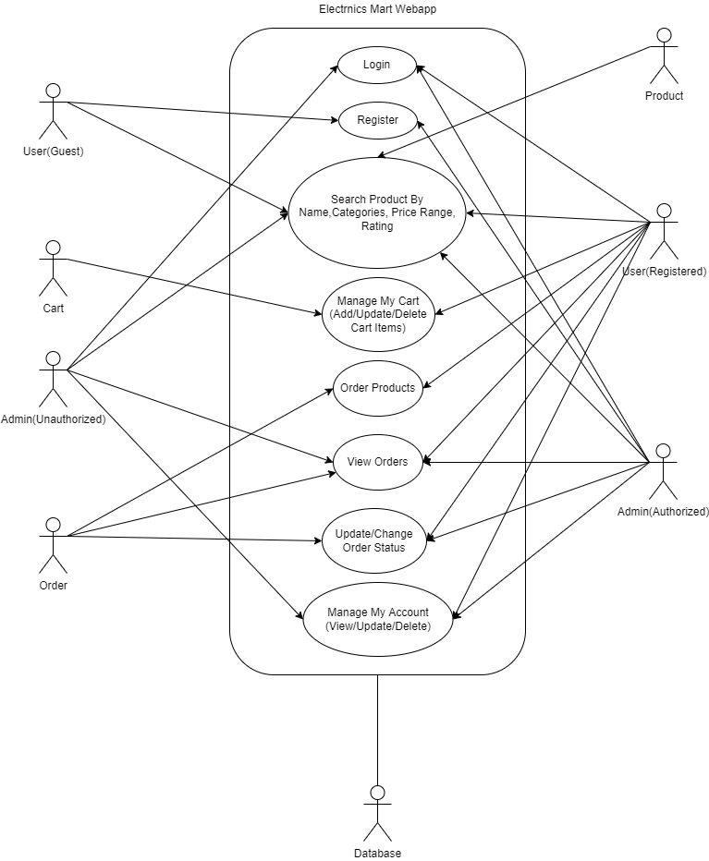

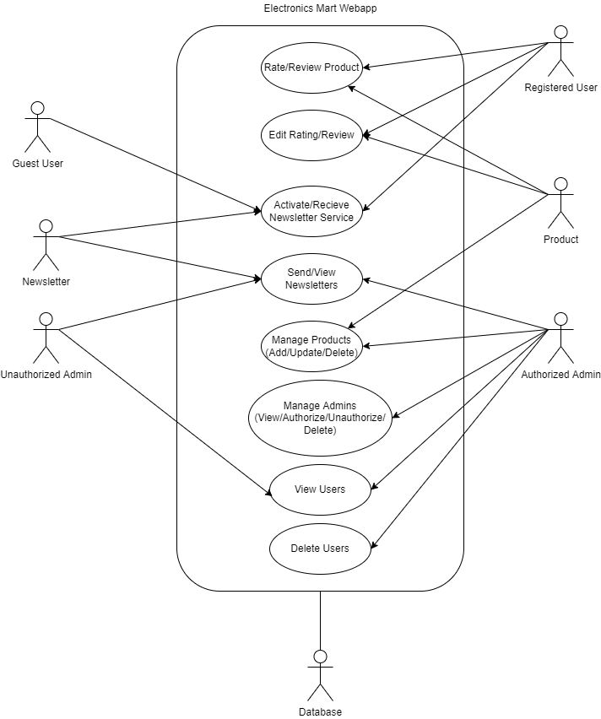

# Other Nonfunctional Requirements

## Performance Requirements

* Use best servers & techniques for data transfer to achieve better performance.
* Use a light-weight frontend so that load on end user device is reduced which will give better performance.
* Minimize redirects on your site by frontend AJAX call through which user will get required data without redirecting.
* Use of projection will remove unnecessary data like createdAt, updatedAt, etc. while sending data from backend to frontend which will reduce size of data to be transferred & therefore less loading time hence achieving better performance.
* Use separate database to store images & save the links of images in there corresponding objects which will enhance performance because the images will only load when end user visits the website & will not travel from database to controller & then controller to frontend.
* Use Indexing on product search as it will gives result faster than normal searching.
* Referral traffic knowledge who sends you the most traffic whether its google or your advertisement – can be very valuable in deciding how to best target the majority of your visitors.

## Safety Requirements

* Maintain a backup of data because in case database server gets crashed or something else happen data could be recovered easily.
* Continues Monitoring is required for proper maintenance of website, in case load on website is at its peak the servers should be upgraded by vertical or horizontal scalability as per requirement & we are using a distributed system so it can be achieved easily.

## Security Requirements

* The password must be encrypted while saving in data base.
* The token-id should expire after 2 Hours.
* A middleware should be plugged in before other routes which requires user’s details for authentication which will authenticate users because we hare using HTTPS protocol which is connectionless.
* Another middleware for admins before admins routes (can only view users, orders, products) and another middleware for authorized admins before authorized admin routes (can manage products, users, orders).
* Another middleware if user has activated Two factor authentication which should check whether user has confirmed otp before entering routes which requires user details.

## Software Quality Attributes

* Testing: The software should be tested for both backend, frontend & after integrations another integration testing should be performed.
* Updates: Updates can be easily managed and joined with distributed node JS system.
* Portability: The software should be portable from one device to another i.e., laptop, mobile, etc.
* Availability: The software is 24X7 available except backend servers may get crashed for that we may deploy the website’s backend on different servers after dividing into different nodes so that whole application doesn’t go down only one or two functions may not work in case server gets crash.

## Business Rules

* User will get mailed on every login so if it’s not the user then the user must change the account password for security as soon as possible.
* The admin has rights to delete any users account if the user is violating any rules.
* The admins can update order status and can cancel the order in case the product is unavailable due to some reason.
* If a user cancels any order, then the product quantity, he cancelled should get added to orignal product quantity.

# Modules

**6.1 User/admin Modules**

6.1.1 Check email

Input – email

Description – This module will check whether the user/admin entering an email for registration is already present in the database or not.

Output – If email is already present, the user will get an email already used message. Else user can complete further registration process.

6.1.2 Register

Input – name, email id, password, address: {house no, city, state, pin code, landmark}, interested in categories

Description – A new user or an authorized admin for registration of a new admin will be using this module to create an account. User/admin needs to provide all the input fields and may also select favorite categories in case of user. a unique id will be generated for each user/admin by using his/her name and this unique id and all the information about the user/admin will be stored in the database collection.

Before saving a password in the database, it should be encrypted for security.

A unique key should be generated & stored in the database, also mapped with the account activation link for generating a unique account activation link for each user/admin & send to them after successful registration on their email id.

Few keys of a new user/admin object should have some by default value –

* account_activated = 0
* two_factor_auth = 0
* otp_checked = 0
* old_pass = password

Output – If all the validations match and data is successfully stored in the database, the user will get a successful prompt and get a successful mail on the entered mail id. Else will get a failure message.

6.1.3 Activate account

Input – key (from the query)

Description – After registering user will get a unique account activation link, once the user clicked on the link the key in the link will be verified from the user object in the database and the account activated key will be equal to 1.

Output – if an account is successfully created, a confirmation mail be sent & a successful message will be displayed on the screen. In case of any errors, the user will get an unsuccessful prompt.

6.1.4 Login

Input – email id, password

Description – this module will verify whether the email id entered is present in the database or not, if its present then it will compare the password with database encrypted password with a 3rd party dependency, if it’s matched it will return the document, same will be checked whether the password is matching to old_pass, if matched it will return the document. If not matched, then the user/admin has entered the wrong password or email.

After getting a document, this module will check whether the account is activated or not.

If activated It will check whether the user/admin has activated two-factor authentication, if activated a 6-digit OTP will be generated, saved in the user/admin document & send to the user/admin email for verification, and redirected to verify OTP page.

If two-factor authentication is not activated a token will be generated with the help of a generate token module and user/admin name and token will be sent.

If the old password has matched, then the name will be sent.

Output – if no document is found with a password or old password then the user/admin will get an invalid email or password prompt message. If user/admin has entered an old password, user/admin will get an old password entered prompt message. If user/admin has entered correct email id, password & activated two-factor auth but due to some error unable to send OTP user/admin will get error prompt message with a token, user/admin name, if user/admin has entered correct email id, password & activated two-factor auth, OTP is sent to registered email then user/admin will get successful login prompt message & email, token, user/admin name. if user/admin entered correct email id, password & two-factor auth is not activated then user/admin will get successful login prompt message & email, token, user/admin name

6.1.5 Check OTP

Input – OTP, token

Description – If user/admin has enabled two-factor authentication, this module receives OTP from user/admin for verification, the OTP will be verified from the database which was sent to user/admin at the time of login to his/her email id. If it is correct, then key “otp_verified” will be updated to 1.

Output – If the OTP is correct, the user will get an OTP verified message and will be able to use website functionalities. Else, the user will get an instant security message on the mail id and the wrong OTP popup on the screen.

6.1.6 Forgot pass

Input – email id

Description – If the user/admin has forgotten their password then this module will help them to recover their account. They need to enter their registered email id, then the application will verify whether this email is in our database or not. If it's present in the database, then the user/admin will get two methods to recover his/her account, by recovery email or recovering account by the previous password. If the user opted for a recovery email, then a unique key will be generated & stored in the database and mapped with account recovery link & sent to the user/admin through email or else if opted for recovery by old password the user/admin will be redirected to account recovery through old password page.

Output – If the email is in the database & user/admin opted for account recovery through email & email is sent then user/admin will get an email successfully sent a prompt else if the email isn’t sent then a failure prompt, if user/admin opted for account recovery though old pass then they will be redirected to another page, if the email is not found in database, then email not found prompt message will be displayed.

6.1.7 Account recovery by email

Input – key, new password

Description – this module will help the user/admin to recover his/her account through the unique account activation link sent to his registered mail. The application will get the key from the link & the new password entered by the user/admin and will verify the key if the key is correct then the current password will become the old password and the new password will be saved as the current password after encryption in the database. Else if the key is not correct then the account can’t be recovered by this method.

If successful, then the user/admin will also get an email for successful account recovery.

After successful account recovery, the user/admin can log in through this new password.

Output – If the key is not correct then the user will get an account recovery unsuccessful prompt message or else if the key is correct then the user will get the account successfully recovered, password updated prompt & an email will be sent.

6.1.8 Account recovery by old password

Input – email, old password, new password

Description – this module will help user/admin to recover his/her account with an old password if he/she remembers, the user/admin has to enter email id, old password & new password so, if the old password matches the encrypted old password saved in that user/admin document in database after decryption, then his old password will be updated by current password & new password will become current password after encryption & saved in the database and an email will be sent about successful account recovery. Else If the old password doesn’t match then the account can’t be recovered by this method.

Output – If the old password is correct & the password has been updated successfully then the user will get a successfully account recovered prompt message & a mail else if the old password doesn’t match user will get an account recovery unsuccessful prompt message.

6.1.9 View my account

Input – token

Description - User/admin can view the account information as well. This module will receive a token to get the user/admin id and will search that id in the database for complete information about the user/admin to be displayed.

Output – User/admin will be displayed the complete account information if successfully found in the database. In case not found then user/admin will get data not found prompt.

6.1.10 Activate two-factor auth

Input – token (for user-id)

Description – User can enable two-factor authentication by this module, user/admin id will be retrieved from token, then “two_factor_auth” key will be equal to 1 in database & after successfully activating the two-factor authentication a mail will be sent to user/admin email id.

Output – If two-factor authentication is enabled, the user will get a confirmation mail and a successful prompt & new token will be set & saved. In case of an error, the user will get an unsuccessful message.

6.1.11 deactivate two-factor auth

Input – token (for user-id)

Description – User can disable two-factor authentication by this module, user/admin id will be retrieved from token, then “two_factor_auth” key will be equal to 0 in database & after successfully deactivating the two-factor authentication a mail will be sent to user/admin email id.

Output – If two-factor authentication is disabled, the user will get a confirmation mail and a successful prompt & new token will be sent & saved. In case of an error, the user will get an unsuccessful message.

6.1.12 Update name

Input – token (for user-id), name

Description – User/admin can update his/her name. By this module name of that user/admin will be updated to the new name in the database.

Output – If the update is successful, the user will get a successful prompt and a new token will be sent & saved. Else, the user will get an unsuccessful prompt message.

6.1.13 Update email

Input – token (for user-id), email

Description – User/admin can update his/her registered email. By this module email of that user/admin will be updated to the new email in the database. A confirmation mail will be sent to the new email of the user/admin. User/admin will be only able to log in through this email after a successful update.

Output – If the update is successful, the user will get a successful prompt and a mail on the mail id new token will be sent & saved. Else, the user will get an unsuccessful message.

6.1.14 Update password

Input – token (for user-id), new password, old password

Description – this module will help to update the password of an account. User/admin must enter old password & new password, email id of user/admin will be retrieved from token & the old password will be matched to the encrypted password in database after decryption, if the password is correct then the old password will be updated to current password & current password will be updated to a new password, a confirmation mail will be sent to user/admin email id about password update. User/admin will be only able to log in through this new password after a successful update.

Output – If the old password is correct & the update is successful, the user/admin will get a successful prompt and a mail on the mail id new token will be sent & saved. Else, the user/admin will get an unsuccessful message accordingly.

6.1.15 Update address

Input – token (for user-id), house no, city, pin code, landmark

Description – In this module user/admin can update his/her address details. The address will be updated to the new address in the database.

Output – If the update is successful, the user/admin will get a successful prompt. Else, the user/admin will get an unsuccessful message.

6.1.16 Delete User/Admin

Input – token (for user-id), password

Description – This module will enable a user/admin to delete his/her electronics mart account. If the password is matched with the encrypted password in the database after decryption, then the user/admin account will be deleted, and this user/admin data will be stored in another collection for 1 year. & key “deleted_by” will have a value “USER_SELF”.

The user’s cart will be permanently deleted, all the orders done by this user will be updated and a key will be added to all his/her orders-

"ACC_DELETED": "this user's account has been deleted"

Output - If delete is successful, user/admin will get a successful prompt and a mail on the registered mail id & user/admin will be redirected to the home page. Else, the user/admin will get an unsuccessful message.

6.1.17 View all users/admin

Input –

Description – An admin can view all the users in the database who have registered on the site. An authorized admin can also view all admins.

Output – If users are found in the database, all the users will be displayed on the page. In case, there is an error or users are not found, the admin will get an unsuccessful prompt message.

6.1.18 View by user-id/admin-id

Input – user-id

Description – An admin can view user details by searching his/her user-id in the database. An authorized admin can also view admin with admin id.

Output – If a user is found in the database with that user-id, the user details will be displayed on the page. In case, there is an error, or a user is not found, the admin will get no such user found prompt message.

6.1.19 View by email id

Input – email id

Description – An admin can view user details by searching his/her email id in the database. An authorized admin can also view admin with that email id.

Output - If a user is found in the database with that email id, the user details will be displayed on the page. In case, there is an error, or a user is not found, then the admin will get no such user found prompt message.

6.1.20 View by name

Input – name

Description – An admin can view the user's list by searching their names. all the users having similar or related names will be displayed in the list. An authorized admin can also view all admins with that name.

Output – If users are found in the database with that name, the user's list will be displayed on the page. In case, there is an error or users are not found, the admin will get no such user found prompt message.

6.1.21 View by pin code

Input – pin code

Description – An admin can view the user's list by searching the pin code, all the users having that pin code in address will be displayed in that list.

Output – If users are found in the database with that pin code, the user's list will be displayed on the page. In case, there is an error or users are not found, then the admin will get no such user found prompt message.

6.1.22 View by city

Input – city

Description – An admin can view the user's list by searching the city, all the users having that city in address will be displayed in that list.

Output – If users are found in the database with that city, the user list will be displayed on the page. In case, there is an error or users are not found, the admin will get no such user found prompt message.

6.1.23 View by state

Input – state

Description – An admin can view the user's list by searching the state, all the users having that state in address will be displayed in that list.

Output – If users are found in the database with that state, the user's list will be displayed on the page. In case, there is an error or users are not found, the admin will get no such user found prompt message.

6.1.24 Delete any user/admin

Input – user-id/admin id, token

Description – An authorized Admin can delete any user/admin by entering the user’s user-id or admin’s admin id if that user/admin violates the T&C of the website. The user/admin will get an email if the account is deleted by an admin. And the user/admin data will be saved in another collection for 1 year.

Admin’s data like admin id, name, email from token will also be saved who has deleted this user/admin account in that another collection for reference.

The user’s cart will be permanently deleted, all the orders done by this user will be updated and a key will be added to all his/her orders-

"ACC_DELETED": "this user's account has been deleted"

Output – On successful deletion, the admin will get a successful message. Else an unsuccessful message

6.1.25 Authorize admin

Input – token, admin id

Description – an authorized admin can authorize any unauthorized admin if required, the admin’s name, admin id, email id who authorized, will be saved in the newly authorized admin document in the database for reference. After the successful update, the newly authorized admin will get a confirmation email.

Output – if admin is authorized then a successful prompt message will be displayed & newly authorized admin will get an email, if the process was not completed due to any issue unsuccessful prompt message will be displayed.

6.1.26 Unauthorize admin

Input – token, admin id

Description – an authorized admin can unauthorize any authorized admin if required, the admin’s name, admin id, email id who unauthorized, will be saved in a newly unauthorized admin document in the database for reference. After the successful update, the newly unauthorized admin will get a confirmation email.

Output – if admin is unauthorized then a successful prompt message will be displayed & newly unauthorized admin will get an email, if the process was not completed due to any issue unsuccessful prompt message will be displayed.

**6.2 Products Modules**

6.2.1 Add product

Input – product name, category, price, image URL, Description, quantity

Description – An admin with all the input details can add a product in the database in which a unique product id is generated by a unique id, product rating & rated by is by default 0.

Output – If products are added successfully, the admin will get a message product is added. Else, a failure message.

6.2.2 View all products

Input – rating (optional)

Description – All the products available in the database will be displayed. If rating Is also mentioned, then the product more than that rating will be displayed otherwise products above rating 0 will be displayed.

Output – The user will be displayed all the products. In case products are not displayed, the user will get a failure prompt.

6.2.3 View by interest

Input – Interested in categories from user data by token, rating (optional)

Description – During the registration process, the user is asked for selecting favorite categories. The products belonging to those categories will be displayed. If rating Is also mentioned, then the product more than that rating will be displayed otherwise products above rating 0 will be displayed.

Output - The user will be displayed all the products. In case products are not displayed, the user will get a failure prompt and there will be no change in products on the screen.

6.2.4 View by name

Input – the name of product, rating (optional)

Description – The user can view a product by searching for the product name. the name of the product is searched in the database with case-sensitive syntax for best results. If rating Is also mentioned, then the product more than that rating will be displayed otherwise products above rating 0 will be displayed and there will be no change in products on the screen.

Output - The user will be displayed the products. In case products are not displayed, the user will get a failure prompt and there will be no change in products on the screen.

6.2.5 View by a single category

Input – the name of the category, rating (optional)

Description – The user can view a product by searching for the product category. If rating Is also mentioned, then the product more than that rating will be displayed otherwise products above rating 0 will be displayed and there will be no change in products on the screen.

Output - The user will be displayed the products. In case products are not displayed, the user will get a failure prompt and there will be no change in products on the screen.

6.2.6 View by multiple categories

Input – the name of all the categories, rating (optional)

Description – User can view a product by searching for multiple product categories. If rating Is also mentioned, then the products more than that rating will be displayed otherwise products above rating 0 will be displayed and there will be no change in products on the screen.

Output - The user will be displayed the products. In case products are not displayed, the user will get a failure prompt and there will be no change in products on the screen.

6.2.7 View by price

Input – price range, rating (optional)

Description – The user can view a product by selecting a price range. If rating Is also mentioned, then the product more than that rating will be displayed otherwise products above rating 0 will be displayed and there will be no change in products on the screen.

Output - The user will be displayed the products. In case products are not displayed, the user will get a failure prompt and there will be no change in products on the screen.

6.2.8 View by rating

Input – rating

Description – The user can view a product by selecting a rating.

Output - The user will be displayed the products. In case products are not displayed, the user will get a failure prompt and there will be no change in products on the screen.

6.2.9 Search by name in a category

Input – name, category, rating (optional)

Description – The user can search for a product by entering a name in the search box and selecting a category. If rating Is also mentioned, the product more than that rating will be displayed otherwise products above rating 0 will be displayed and there will be no change in products on the screen.

Output – The user will be displayed the products. In case products are not displayed, the user will get a failure prompt and there will be no change in products on the screen.

6.2.10 Search by name in multiple categories

Input – name, categories, rating (optional)

Description – User can search a product by entering a name in the search box and selecting multiple categories. If rating Is also mentioned, the product more than that rating will be displayed otherwise products above rating 0 will be displayed and there will be no change in products on the screen.

Output – The user will be displayed the products. In case products are not displayed, the user will get a failure prompt and there will be no change in products on the screen.

6.2.11 View by price & categories

Input –price, categories, rating (optional)

Description – The user can view a product by selecting a category and a price. If rating Is also mentioned, the product more than that rating will be displayed otherwise products above rating 0 will be displayed and there will be no change in products on the screen.

Output – The user will be displayed the products. In case products are not displayed, the user will get a failure prompt and there will be no change in products on the screen.

6.2.12 View by product id

Input –product id

Description – User can view a product detail by this feature, the front-end application will automatically send a product id when any product is selected by the user to view.

Output – The user will be displayed the products. In case products are not displayed, the user will get a failure prompt.

6.2.13 Rate product

Input – product id, rating

Description – In this module a user can rate a product once the product is delivered to his address. user details like user-id will be retrieved from token, this module also checks whether that user has already rated that product or not, if not then the average rating of that product is updated by simple Mathematical equation, and product rated by is also increased by 1. The rating given by the user is saved in the user’s order for future reference if the user wants to change the rating given by him.

Output – If the rating is successful, the user will get a successful prompt. Else if a product is already rated, then the user will get an already rated prompt message. Or else an unsuccessful prompt.

6.2.14 Edit rating

Input – product id, rating

Description – User can only edit rating given by him/her earlier, user details like user-id will be retrieved from token, his previous rating is obtained from product order as saved earlier and the average product rating will be updated by a simple mathematical equation which will be deleting the previous rating from average and adding a new rating.

Output – If the rating is successful, the user will get a successful prompt. Else if a product is not rated earlier, then the user will get a product not rated prompt message. Or else an unsuccessful prompt.

6.2.15 Review product

Input – product id, review

Description – In this module, a user can review a product once the product is delivered to his address. user details like user-id will be retrieved from token, any review will be added to the list of the reviews of the product which stores a review mapped with that user’s id.

Output – If the review is successful, the user will get a successful prompt. Else if a review is already added, then the user will get an already reviewed prompt message. Or else an unsuccessful prompt.

6.2.16 Edit review

Input – product id, review

Description – The user can only edit a review of a product given by him earlier by adding a new product review which will overwrite the previous review given by him. user details like user-id will be retrieved from the token.

Output – If the review is successful, the user will get a successful prompt. Else if a product is not reviewed, then the user will get a product not reviewed prompt message. Or else an unsuccessful prompt.

6.2.17 Update Product

Input – product name, price, image, description, category

Description – authorized admin can update any product with the help of this module, the new entered by the admin will be replaced with the old fields of that particular product and saved in database except product id. Product price should be greater than or equal to 0.

Output – if product is updated successfully then a successfully updated prompt message will be displayed else update unsuccessful prompt message will be displayed.

6.2.18 Update quantity

Input – product id, product quantity

Description – this module will help an authorized admin to update quantity of a product as per the availability of product in stock. the product quantity entered by the admin will be added to the previous quantity, if quantity added by the admin is in negative that means product quantity will be reduced by that much, but total product quantity can’t be less than 0.

Output – if product quantity is updated successfully then a successfully updated prompt message will be displayed else update unsuccessful prompt message will be displayed.

6.2.19 Delete Product

Input – Product id

Description – authorized admin can delete any product present in database.

Output - if product is deleted successfully then a successfully deleted prompt message will be displayed else delete unsuccessful prompt message will be displayed.

**6.3 Order Product Modules**

6.3.1 Order product

Input –Token, product id, product quantity

Description –When a user orders a product, order details like product id, user-id, quantity and retrieve email address, full name, user-id from token, unique order id is generated by unique id despondency & stored in the orders collection in the database and from the products database, product quantity is reduced.

Output – If an order is successful, the user will get a successful prompt and a mail on the registered id with the order in the mail body, and if the order can’t be placed, the user will get a prompt that the order is unsuccessful.

6.3.2 View One Order (by user)

Input – order id, token (for user-id)

Description – A user can check the status of order with the order id which is automatically filled by the front end. The application will check the order id with that user-id from the orders database.

Output – If an Order is found, the user will get all the order details on the screen. Else if there is a mistake in the order id, the user will get an order not found prompt.

6.3.3 View orders (by user)

Input – token (for user-id)

Description - A user can check all the orders. The application will return all the orders placed by that user-id.

Output– If Orders are found, the user will get all the order details on the screen. If unsuccessful, the user will get an order not found prompt.

6.3.4 Change order status (by user)

Input – token (for user-id), order id, new order status (CANCEL/RETURN)

Description – A user can change the order status to CANCEL/RETURN of the order if he wants to cancel or return an order. Mail is also sent to the user email giving details about the new order status. If an order is canceled the product quantity is increased by the quantity of product in this order.

Output – If the status is changed, the status will get changed. Else the user will get a prompt that it is unsuccessful.

6.3.5 View all orders (by admin)

Input – none

Description – An admin can view all the orders that are placed by all the users combined

Output- If successful, all the orders will be displayed, else the admin will get an unsuccessful prompt message on the screen.

6.3.6 View orders by user (by admin)

Input – user-id

Description – An admin can view all the orders placed by a particular single user in this module.

Output – If successful, all the orders will be displayed, else the admin will get an unsuccessful prompt message on the screen.

6.3.7 View orders by product id (by admin)

Input – product id

Description – An admin can view all the orders placed for a specific product.

Output – If successful, all the orders will be displayed, else the admin will get an unsuccessful prompt message on the screen.

6.3.8 View single order (by admin)

Input – order id

Description – An admin can view a specific order with details by looking for the order id in the database.

Output – If successful, order will be displayed, else admin will get an unsuccessful prompt message on the screen.

6.3.9 Search Order by order status

Input – order status

Description – Admin can view all the orders with order status.

Output – If successful, all the orders will be displayed, else admin will get an unsuccessful prompt.

6.3.10 Update order status (by admin)

Input – order id, new order status

Description – Admin can change the order status of an order as described in the requirement. The user will get an email about an update in order status. If an order is canceled the product quantity is increased by the quantity of product in this order.

Output - If successful, order status will be changed for both user and admin and the user will also receive a mail with updated status. Else admin will get an unsuccessful prompt.

**6.4 Cart Modules**

6.4.1 Add to cart

Input – product object (containing product id & quantity), token

Description – an empty user cart is already created at the time of user registration; cart id is the same as user-id for efficiency & easy mapping that will be stored in cart object. product object is pushed into products array of cart object. A cart object has an array that contains product objects. If the user click adds to cart it first checks whether that product is in stock for that much quantity user-selected & then looks for that product is already in its cart of that user or not. If it is existing in the array, then it will simply increase the quantity of that product in the cart else that product is pushed into the product's array.

Output – If the product is added to the cart, the user will get a successful prompt. Else if the product is not in enough quantity user will get a product out of stock prompt. Or else an unsuccessful prompt.

6.4.2 View my cart

Input – token

Description – The user can view his cart items with the help of this module.

Output – User will be displayed cart. In case the cart is not displayed user will get an unsuccessful prompt.

6.4.3 View one cart item

Input – product id, token

Description – cart id is the same as user id which will be retrieved from token. Users can view a detailed view of any cart item.

Output – User will be displayed that cart item. If not, then the user will get an unsuccessful prompt.

6.4.4 Search in cart

Input – name, token

Description – User can search any product in his/her cart by name.

Output – user will be displayed that cart item. If there is no product in the cart with that named user will get a not found prompt. Or else an unsuccessful prompt.

6.4.5 Delete cart item

Input – product id, token

Description - cart id is the same as user id which will be retrieved from token & the product with this product id which is selected by the user will be deleted (pop) from the products array of the cart.

Output – If a cart item is deleted user will get a successful prompt. Or else an unsuccessful prompt.

6.4.6 Delete user cart

Input – token

Description - cart id is the same as user id which will be retrieved from token. Users can delete their all-cart items at once if needed with the help of this module.

Output - if all cart items are deleted user will get a successful prompt. Or else an unsuccessful prompt.

6.4.7 Update user Cart

Input – token (for user id), product id, product quantity

Description - user can update quantity of any item in cart by the help of this module.

Output – if quantity is updated then user will be displayed updated quantity otherwise user will get unsuccessful update message prompt.

**6.5 Newsletter Modules**

6.5.1 Activate Newsletter Service

Input – email address

Description – After users enter the email address, a function checks whether the email address is present in the newsletter collection of the database. If not present, it will store emails in the collection and activate the service & it will mail the user with a success message.

Output – If activated it will prompt a successful message, Else if the service is already activated, it will prompt the user that the service is already activated.

6.5.2 Send Newsletters

Input – Subject, Body, Email addresses, token

Description – An admin (after being verified through token) can add subject, body, and send the newsletter to all the email addresses which are present in newsletter collection & to the emails of all registered emails (will not send an email twice if an email is in both collections). After sending it will save the newsletter, list of recipients & who send this email in another collection.

Output – If successful, it will prompt the admin that emails were sent successfully sent, else it will prompt those emails were not sent.

6.5.3 View All

Input – none

Description – An admin can check all the emails that were sent earlier to the users.

Output – This module returns all the emails that were sent to the users as the output

**6.6 Common Modules**

6.6.1 Authentication

Input – token from headers under authorization key.

Description – it checks whether the token is empty or not, if not empty it verify the token with the help of another module.

Output – if the token is valid, the user can go further, else the user will be displayed an unauthorized prompt & redirected to the login page for authentication.

6.6.2 Two-factor authentication

Input - token from headers under authorization key.

Description – If the user has activated two-factor authentication & has verified the latest OTP only then this module will let the user access the website features that require user data. if two-factor authentication is not activated the user can go further.

Output – if OTP is not verified user will get an OTP not verified prompt & will be redirected to the OTP verification page. Else user can access services.

6.6.3 Admin authentication

Input - token from headers under authorization key.

Description – This module verifies whether a person is an admin or not with the help of verify admin module. if get success through verify admin module that means this is an admin who can access admin functionalities.

Output – if not the user will get an unauthorized prompt & redirected to the login page.

6.6.4 Authorized Admin Authentication

Input - token from headers under authorization key.

Description – This module verifies if this admin is authorized or not with the help of verify authorized admin module. If it gets success through verify authorized admin module that means this is an authorized admin who can access all admin functionalities.

Output - if not, the admin will get an unauthorized prompt & redirected to the login page.

6.6.5 Encrypt

Input – password or encrypted password

Description – this module has 2 functions. One function is for converting passwords into encrypted passwords & another one will decrypt & check the encrypted password with the password for security & verification.

Output – it will return encrypted password for password as input, true or false based on comparison after decryption.

6.6.6 Nodemailer

Input – email, subject, body

Description – this module is used for mail service.

Output – sends mail or if there’s some error it will show an error in the console.

6.6.7 Generate token

Input – user details, secret string

Description – by using 3rd party dependency (JWT) this module will generate a token from user details & a secret string, this secret string should be unique so that the token should not conflict with any other website token. This token will expire in 2 hours for better security.

Output – unique token

6.6.8 Verify Token

Input – token, secret string

Description – this module will verify the user/admin by token after decoding it with the help of 3rd party dependency, will check whether the token contains user/admin object & our secret string and should not be expired.

Output – if the token is correct and not expired it will return true, else if the token is invalid in any way or expired it will return false.

6.6.9 Verify Admin Token

Input – token, secret string

Description – This module will verify the admin by token after decoding it with the help of 3rd party dependency, will check whether the token is containing an admin object & our secret string and should not be expired as well.

Output – if the token is containing the admin object & is not expired then it will return true, else if the token is invalid or is expired, it will return false.

6.6.10 Verify Authorized Admin

Input – token, secret string

Description – This module will verify the authorized admin by token after decoding it with the help of 3rd party dependency, will check whether the token is containing an admin object with “isadmin” key equal to “1”, our secret string, and should not be expired.

Output – if the token is correct & isadmin is equal to 1 and not expired then it will return true, else if it’s invalid, isadmin is not equal to 1 or not found or is expired then it will return false.

6.6.11 Generate key

Input – secret string

Description – This module helps to create a unique key with the help of 3rd party dependency for functionalities like account activation or account recovery where a unique key is required & should get expired in a limited time after 2 hours.

Output – If the key is generated successfully then it returns a unique key, else at least possible it may give some error.

6.6.12 Verify key

Input – key, secret string

Description – This module will verify the key with the help of 3rd party dependency whether it is correct or not or it is containing the secret string & should not be expired.

Output – if the key is correct & not expired it will return true else if the key isn’t correct or is expired it will return false.

6.6.13 Get doc

Input – token, secret string

Description – this module will decode the token with the help of 3rd party dependency. If the token is correct, then it will return the user/admin object containing their information. By this, we are reducing I/O operations through the database which will improve performance & reduce loading time also.

Output – If the token is correct & not expired, it will return the complete user/admin object, else error

# Other Requirements

Electronics Mart shall handle expected & unexpected errors in ways that prevent loss in information & long downtime period.

Appendix A: Glossary

* ODM – object data manipulation which is basically manipulating data when it's transferred from database to application & vice-versa.
* Middleware – It’s a functionality which can be added to the application anywhere it’s required whose task is to perform a specific action.
* Unauthorized Amin – basically these are new admins who have rights to only read database like they can view users, products, orders.
* Authorized Admins – these admins have full rights to do anything, they can register any admin, authorize/unauthorize any admins, manage products, modify order status, manage users, etc.
* Token – token is used to verify the correct user as we are using HTTPS protocol which is connectionless approach, this token contains an object of user details, so that we can get user info more quickly from this token rather than doing database operation for each & everything.

Appendix B: Analysis Models

Electronics Mart Database

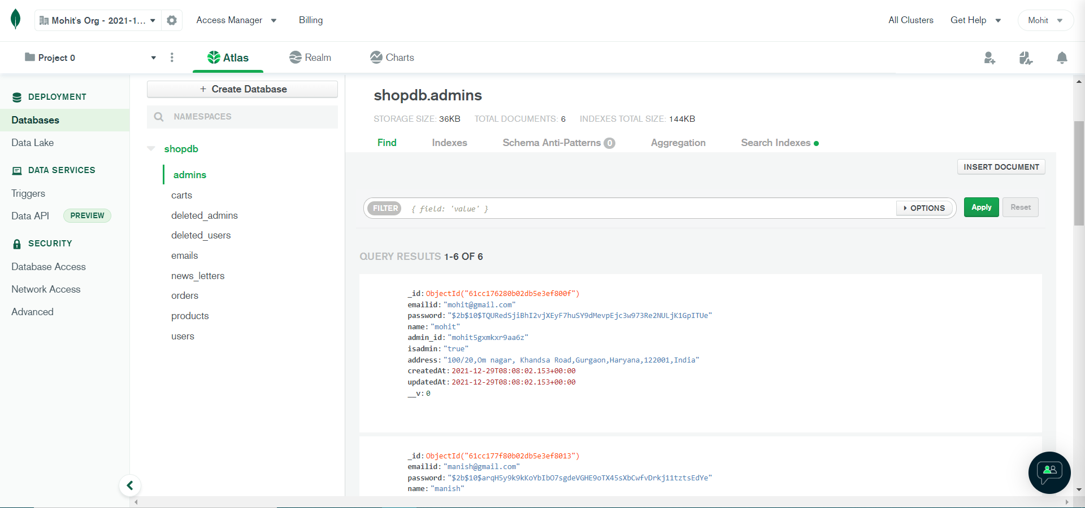

**EXPERIMENT NO. 4**

|  |
| --- |
| **Student Name and Roll Number:**  Deepanshu Goel, Manish Kumar Sharma, Mohit Malik, Namit Kumar, Pearl Arora  19CSU077, 19CSU173, 19CSU179, 19CSU185, 19CSU208 |
| **Semester /Section:**  6/FS-A-1 |
| **Link to Code:** |
| **Date:** |
| **Faculty Signature:** |
| **Marks:** |
| **Objective:**   * Study the benefits of visual modeling. * Learn use case diagrams: discovering actors and discovering use cases. * Practice use cases diagrams using CASE tool. |
| **Outcome:**  Students will understand the importance of SEPM and about various software artifacts  Students will learn to perform feasibility analysis by designing Feasibility Study Document |
| **Problem Statement:**  Draw the use case diagram of your project by identifying primary, secondary actors and use cases. |
| **Background Study:**  **Basic elements used in use case diagram:** Actor The **use case diagram** allows a designer to graphically show these use cases and the actors that use them.  An **actor** is a role that a user plays in the system.  It is important to distinguish between a user and an actor (better thought of as a role).  A user of the system may play several different roles through the course of his, her or its job (since an actor may be another system).  Examples of actors are salesperson, manager, support person, and web store system.  It is possible that the same person may be a salesperson and also provide support.  When creating a use case model, we are not concerned with the individuals, only the roles that they play.  Actors can be of two types:   * Primary actors, using system in daily activities * Secondary actors, enabling primary actors to use a system.   **How do you know who the actors are in a UCD?**  When working from an Action/Response table, identifying the actors is easy: entities whose behavior appears in the "Actor's Actions" column are the actors, and entities whose behavior appears in the "System's Response" column are components in the system.  the actors are typically those entities whose behavior cannot control or change (i.e., agents that are not part of the system that you are building or describing.) Use cases **A use case**   * Constitutes complete course of events initiated by actor * Defines interaction between actor and the system * Is a member of set of all use cases which together define all existing ways of using the system   **How to select the use cases:**  Consider the simple scenario in which a photographer takes the picture. So the use cases will be Take picture and Change film not that first he/she opens the shutter, then take picture and then close shutter. These do not focus on the functionality of the photographer.  http://www.andrew.cmu.edu/course/90-754/camera.jpg  **Figure 1: Use case diagram (example)** Associations On a use case diagram, associations are drawn between actors and use cases to show that an actor carries out a use case.  A use case can be carried out by many actors and an actor may carry out many use cases.  http://www.visualcase.com/tutorials/images/Use-Case-Associations.jpg  In this diagram associations between actors and use cases are represented by the connecting lines.  The developer and the stakeholder both are responsible for specifying the system roles, but only the developer creates the model. Includes Use cases can also be related to each other with different links.  The diagram below shows the use of the includes link. The best way to think of an include dependency is that it is the invocation of a use case by another one. In this figure both *invoice purchase* and *online purchase* include the scenarios defined by *purchase valuation*.  In general, the includes link is to avoid repetition of scenarios in multiple use cases.  http://www.visualcase.com/tutorials/images/IncludesLink.jpg Generalization When a use case describes a variation on another use case, use a generalization link.  In the example below, the use case *limit exceeded* describes a situation in which the usual scenario of *online purchase* is not performed.  Use cases that generalize another use case should only specify an alternative, even exceptional, scenario to the use case being generalized.  The overall goal of the use cases should be the same.  http://www.visualcase.com/tutorials/images/GeneralizationLink.jpg Extends In some instances you want to describe a variation on behaviour in a more controlled form.  In such instances you can define **extension points** in the extended use case.  An extending **use case** continues the behavior of a base use case. The extending use case accomplishes this by conceptually inserting additional action sequences into the base use-case sequence. This allows an extending use case to continue the activity sequence of a base use case when the appropriate extension point is reached in the base use case and the extension condition is fulfilled. When the extending use case activity sequence is completed, the base use case continues.  In the example below, *search by name* is said to extend *search* at the *name* extension point. The extended link is more controlled than the generalization link in that functionality can only be added at the extension points.  ***An extends relationship shows optional/exceptional behavior***  http://www.visualcase.com/tutorials/images/ExtendsLink.jpg |
| **Question Bank:**   * + - 1. **Differentiate between primary and secondary actors.**   The primary actor is who receives the primary benefit from interacting with the system. The primary actor is the user with a goal to be accomplished by interacting with the system. The secondary actors are users or external systems which support the system in accomplishing the primary goal. For example, the secondary actor may provide information to the system needed to produce the information desired by the primary actor.   * + - 1. **Draw the use case diagram of courseware management system.**   use case Activity Diagram For Course Management System complete Class Diagram-Course Registration Below Figure (14) |

**Student Work Area**

**Algorithm/Flowchart/Code/Samp**



**EXPERIMENT NO. 5**

|  |
| --- |
| **Student Name and Roll Number:**  Deepanshu Goel, Manish Kumar Sharma, Mohit Malik, Namit Kumar, Pearl Arora  19CSU077, 19CSU173, 19CSU179, 19CSU185, 19CSU208 |
| **Semester /Section:**  6/FS-A-1 |
| **Link to Code:** |
| **Date:** |
| **Faculty Signature:** |
| **Marks:** |
| **Objective:**  Learn the object-oriented analysis phase by understanding the methods of class elicitation and finding the classes in an object-oriented system. |
| **Outcome:**  Students will learn to discover the classes and mapping from use case to class diagram. |
| **Problem Statement:**  Draw the class diagram of mentioned project by discovering classes. |
| **Background Study:**  A class diagram gives an overview of a system by showing its classes and the relationships among them. Class diagram are static-they display what interacts but not what happens when they do interact. **Class diagram address the static design view of the system. Class diagram that include active classes address the static process view of a system**. Classes define the properties of the objects, which belongs to them.  These include:  **Attributes**-(second container)t he data properties of the classes including type, default value and constraints  **Operations**-(third container) the signature of the functionality that can be applied to the objects of the classes including parameters, parameter types, parameter constraints, return types and the semantics.  **Associations**-(solid lines between classes) the references contained within the objects of the classes to other objects enabling interaction with those objects. So, the purpose of the class diagram can be summarized as:   * Analysis and design of the static view of an application. * Describe responsibilities of a system. * Base for component and deployment diagrams. * Forward and reverse engineering.  Build the class diagram: Till now we have use cases which show that what the system do?  Now the next step is to design the system which means try to find the answer that:   * How the system does accomplish its goal?   + Find the responsibilities from requirements, and distribute them over classes. * Identifying the classes:   + Actors are primary entities in the system and they will be mapped on classes.   + Also we have passive entities, also they will be mapped to classes. * Identify the relationships among classes  Basic Class Diagram Symbols and Notations Classes represent an abstraction of entities with common characteristics. Associations represent the relationships between classes.  Illustrate classes with rectangles divided into compartments. Place the name of the class in the first partition (centered, bolded, and capitalized), list the attributes in the second partition, and write operations into the third.  **Active Class**  Active classes initiate and control the flow of activity, while passive classes store data and serve other classes. Illustrate active classes with a thicker border.  **Visibility**  Use visibility markers to signify who can access the information contained within a class. Private visibility hides information from anything outside the class partition. Public visibility allows all other classes to view the marked information. Protected visibility allows child classes to access information they inherited from a parent class.  **Associations**  Associations represent static relationships between classes. Place association names above, on, or below the association line. Use a filled arrow to indicate the direction of the relationship. Place roles near the end of an association. Roles represent the way the two classes see each other. **Note:** It's uncommon to name both the association and the class roles.  **Multiplicity (Cardinality)**  Place multiplicity notations near the ends of an association. These symbols indicate the number of instances of one class linked to one instance of the other class. For example, one company will have one or more employees, but each employee works for one company only.  **Constraint**  Place constraints inside curly braces {}.   Simple Constraint  **Composition and Aggregation**  Composition is a special type of aggregation that denotes a strong ownership between Class A, the whole, and Class B, its part. Illustrate composition with a filled diamond. Use a hollow diamond to represent a simple aggregation relationship, in which the "whole" class plays a more important role than the "part" class, but the two classes are not dependent on each other. The diamond end in both a composition and aggregation relationship points toward the "whole" class or the aggregate.  **Generalization**  Generalization is another name for inheritance or an "is a" relationship. It refers to a relationship between two classes where one class is a specialized version of another. For example, Honda is a type of car. So the class Honda would have a generalization relationship with the class car.  *In real life coding examples, the difference between inheritance and aggregation can be confusing. If you have an aggregation relationship, the aggregate (the whole) can access only the PUBLIC functions of the part class. On the other hand, inheritance allows the inheriting class to access both the PUBLIC and PROTECTED functions of the superclass.* |
| **Question Bank:**  **Differentiate between active and passive classes**   |  |  | | --- | --- | | Active | A active object owns a thread of control and can initiate control activity. Processes and tasks are types of active objects. | | Passive | A passive object holds data, but does not initiate control. |   **Draw the class and object diagram for courseware management system**   |

**Student Work Area**

**Algorithm/Flowchart/Code/Sample Outputs**

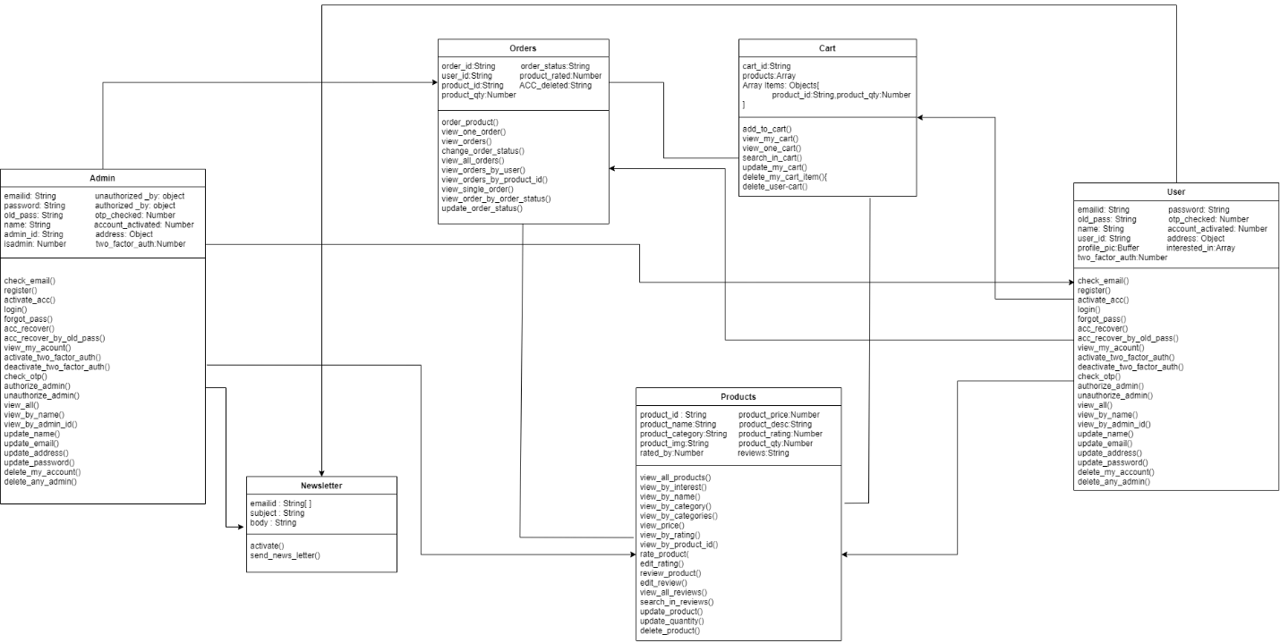

**EXPERIMENT NO. 6**

|  |
| --- |
| **Student Name and Roll Number:**  Deepanshu Goel, Manish Kumar Sharma, Mohit Malik, Namit Kumar, Pearl Arora  19CSU077, 19CSU173, 19CSU179, 19CSU185, 19CSU208 |
| **Semester /Section:**  6/FS-A-1 |
| **Link to Code:** |
| **Date:** |
| **Faculty Signature:** |
| **Marks:** |
| **Objective:**   * Deeper understanding of UML state transition diagrams (STD). * Practicing using CASE tool. |
| **Outcome:**  Students will learn to design the state and activity diagrams. |
| **Problem Statement:**  Draw the state and activity diagrams of mentioned project. |
| **Background Study:**  While coding, it is necessary to understand the details of the modes an Object of a Class can go through and its transitions at time intervals with the occurrence of any event or action.  State diagrams (also called State Chart diagrams) are used to help the developer better understand any complex/unusual functionalities or business flows of specialized areas of the system. In short, State diagrams depict the dynamic behavior of the entire system, or a sub-system, or even a single object in a system. This is done with the help of Behavioral elements.  It is important to note that having a State diagram for your system is not a compulsion, but must be defined only on a need basis  State diagrams have very few elements.  State diagrams have very few elements.  The basic elements are rounded boxes representing the state of the object and arrows indicting the transition to the next state.  The activity section of the state symbol depicts what activities the object will be doing while it is in that state.  All state diagrams being with an initial state of the object.  This is the state of the object when it is created.  After the initial state the object begins changing states.  Conditions based on the activities can determine what the next state the object transitions to.    Below is an example of a state diagram might look like for an Order object.  When the object enters the Checking state it performs the activity "check items."  After the activity is completed the object transitions to the next state based on the conditions [all items available] or [an item is not available].  If an item is not available the order is canceled.  If all items are available then the order is dispatched.  When the object transitions to the Dispatching state the activity "initiate delivery" is performed.  After this activity is complete the object transitions again to the delivered state.  Figure- State diagram for an order object  State diagrams can also show a super-state for the object. A super-state is used when many transitions lead to the a certain state.  Instead of showing all of the transitions from each state to the redundant state a super-state can be used to show that all of the states inside of the super-state can transition to the redundant state.  This helps make the state diagram easier to read.  The diagram below shows a super-state.  Both the Checking and Dispatching states can transition into the Canceled state, so a transition is shown  from a super-state named Active to the state Cancel.  By contrast, the state Dispatching can only transition to the Delivered state, so we show an arrow only from the Dispatching state to the Delivered state.    Figure: state diagram showing super state Activity Diagram: Activity diagram are fancy flowcharts. Activity diagrams represent the business and operational workflows of a system. An Activity diagram is a dynamic diagram that shows the activity and the event that causes the object to be in the particular state. Creating an Activity Diagram Let us consider the example of attending a course lecture, at 8 am.  UML0701  Figure —an example Activity diagram  As you can see in Figure 6 the first activity is to get dressed to leave for the lecture. A decision then has to be made, depending on the time available for the lecture to start, and the timings of the public trains (metra). If there is sufficient time to catch the train, then take the train; else, flag down a cab to the University. The final activity is to attend the lecture, after which the Activity diagram terminates.  Swim Lanes:  Activity diagrams provide another ability, to clarify which actor performs which activity. If you wish to distinguish in an Activity diagram the activities carried out by individual actors, vertical columns are first made, separated by thick vertical black lines, termed "swim lanes," and name each of these columns with the name of the actor involved. You place each of the activities below the actor performing these activities and then show how these activities are connected.  *A state chart diagram shows the possible states of the objects and the transition that cause a change in the state.*  *An activity diagram are related to state chart diagram except that state chart diagram focuses attention on an object undergoing a process(or on a process as an object), an activity diagram focuses on the flow of activities involved in a single process. The activity diagram shows the how those activities depend on one another.* |
| **Question Bank:**   1. Differentiate between activity diagram and state chart diagram   Activity Diagrams are reducible to State Machines with some additional notations that the vertices represent the carrying out of an activity and the edges represent the transition on the completion of one collection of activities to the commencement of a new collection of activities. Activity Diagrams capture high level activities aspects. In particular, it is possible to represent concurrency and coordination in Activity Diagrams. |

**Student Work Area**

**Algorithm/Flowchart/Code/Sample Outputs**

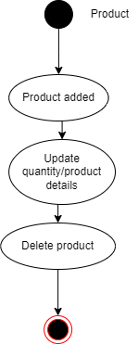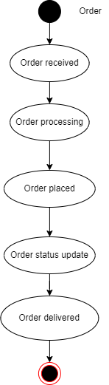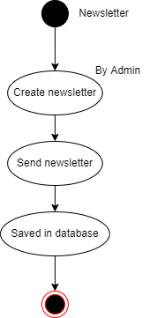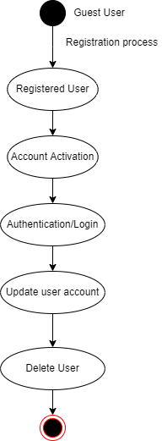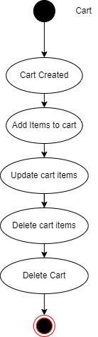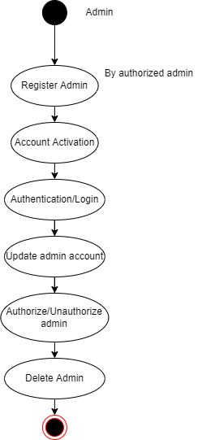

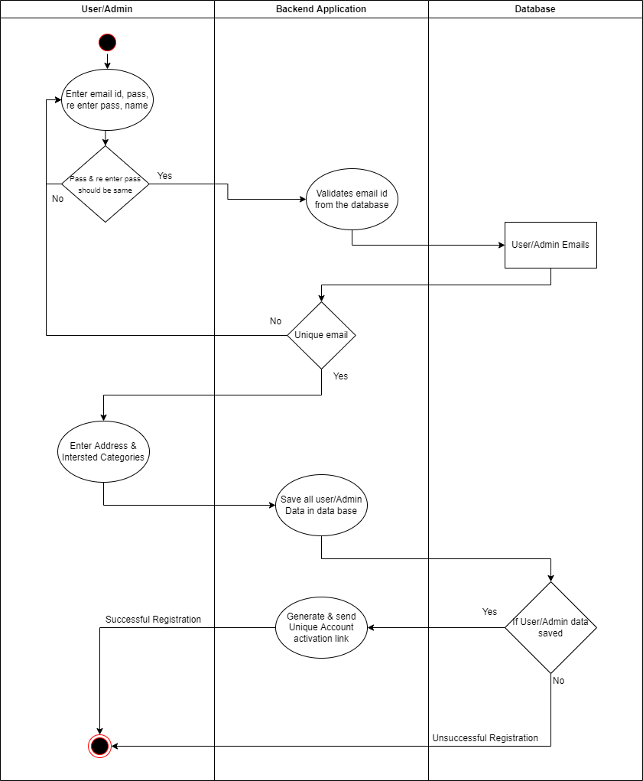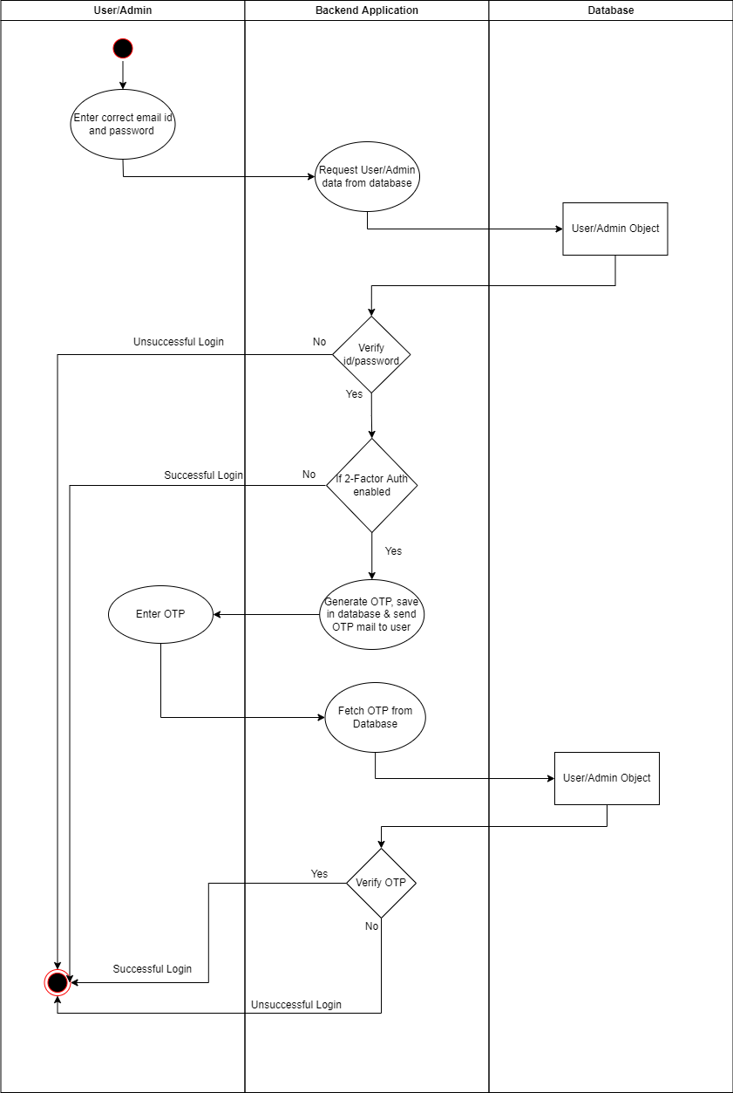**EXPERIMENT NO. 7**

|  |
| --- |
| **Student Name and Roll Number:** |
| **Semester /Section:** |
| **Link to Code:** |
| **Date:** |
| **Faculty Signature:** |
| **Marks:** |
| **Objective:**  Better understanding of the interaction diagrams.  Get familiar with sequence & collaboration diagrams.  Practice drawing the interaction diagrams using CASE tool. |
| **Outcome:**  Students will learn to design sequence and collaboration diagrams. |
| **Problem Statement:**  Draw the sequence and collaboration diagrams of mentioned project. |
| **Background Study:**  *A use case diagram presents an* ***outside*** *view of the system.*  *Then, how about the* ***inside*** *view of the system?*  Interaction diagrams describe how use cases are ***realize***d in terms of interacting objects.  Two types of interaction diagrams   1. Sequence diagrams 2. Collaboration *(Communication)* diagrams   Once the use cases are specified, and some of the core objects in the system are prototyped on class diagrams, we can start designing the dynamic behavior of the system.  Let's start with the simple example above: a user logging onto the system.  The Logon use case can be specified by the following step:   1. Logon dialog is shown 2. User enters user name and password 3. User clicks on OK or presses the enter key 4. The user name and password are checked and approved 5. The user is allowed into the system   Alternative: Logon Failed - if at step 4 the user name and password are not approved, allow the user to try again  **Figure- An example sequence diagram for our logon collaboration** Collaboration Diagrams Collaborations are more complex to follow than sequence diagrams, but they do provide the added benefit of more flexibility in terms of spatial layout.  A Sequence diagram is dynamic, and, more importantly, is time ordered. A Collaboration diagram is very similar to a Sequence diagram in the purpose it achieves; in other words, it shows the dynamic interaction of the objects in a system. A distinguishing feature of a Collaboration diagram is that it shows the objects and their association with other objects in the system apart from how they interact with each other. The association between objects is not represented in a Sequence diagram.  A Collaboration diagram is easily represented by modeling objects in a system and representing the associations between the objects as links. The interaction between the objects is denoted by arrows. To identify the sequence of invocation of these objects, a number is placed next to each of these arrows.  **Defining a Collaboration diagram**  A sophisticated modeling tool can easily convert a collaboration diagram into a sequence diagram and the vice versa. Hence, the elements of a Collaboration diagram are essentially the same as that of a Sequence diagram.  Let us see in detail what the elements of Collaboration diagram are.  **Figure-:A Collaboration diagram for Logon** i**nteraction .**  Notice that each message is numbered in sequence, because it is not obvious from the diagram, the order of the messages.  *Sequence diagrams emphasize the order in which things happen, while collaboration diagrams give more flexibility in their layout.  You can use whichever you prefer when drawing interactions, as both show the same information.* |
| **Question Bank:**   1. Draw the interaction diagrams for courseware management system 2. Differentiate between activity diagram and state chart diagram |

**Student Work Area**

**Algorithm/Flowchart/Code/Sample Outputs**

**EXPERIMENT NO. 8**

|  |
| --- |
| **Student Name and Roll Number:** |
| **Semester /Section:** |
| **Link to Code:** |
| **Date:** |
| **Faculty Signature:** |
| **Marks:** |
| **Objective:**   * Gain a deeper understanding of software testing and the software testing document. * Become familiar with a Test Plan Document |
| **Outcome:**  Test Plan document using excel. |
| **Problem Statement:**  Write the test cases (minimum 10) for Traffic Light System /your defined project |
| **Background Study:**  Testing is the process of executing a program with the intent of finding errors. A good test case is one with a high probability of finding an as-yet undiscovered error. A successful test is one that discovers an as-yet-undiscovered error.  The causes of the software defects are: specification may be wrong; specification may be a physical impossibility; faulty program design; or the program may be incorrect.  **Basic Definitions**   * **A failure** is an unacceptable behavior exhibited by a system. * **A defect** is a flaw in any aspect of the system that contributes, or may potentially contribute, to the occurrence of one or more failures. It might take several defects to cause a particular failure. * **An error** is a slip-up or inappropriate decision by a software developer that leads to the introduction of a defect.   **Good Test Attributes**  A good test has a high probability of finding an error, not redundant, and should not be too simple or too complex.  The characteristics of a Banking application are as follows:   * Multi tier functionality to support thousands of concurrent user sessions * Large scale Integration , typically a banking application integrates with numerous other applications such as Bill Pay utility and Trading accounts * Complex Business workflows * Real Time and Batch processing * High rate of Transactions per seconds * Secure Transactions * Robust Reporting section to keep track of day to day transactions * Strong Auditing to troubleshoot customer issues * Massive storage system * Disaster Management.   **Test Cases**  File Open - Test case Steps to reproduce: 1. Launch Application 2. Select "File" menu  File menu pulls down 3. Choose "Open"  "Open" dialog box appears 4. Select a file to open 5. Click OK Result: File should open Test case Test case ID: B 001 Test Description: verify B - bold formatting to the text  Function to be tested: B - bold formatting to the text  Environment: Win 98 Actual Result: pass |
| **Question Bank:**  **Explain the complete test bug life cycle and discuss the importance of test document for that** |

**Student Work Area**

**Algorithm/Flowchart/Code/Sample Outputs**

**EXPERIMENT NO. 9**

|  |
| --- |
| **Student Name and Roll Number:** |
| **Semester /Section:** |
| **Link to Code:** |
| **Date:** |
| **Faculty Signature:** |
| **Marks:** |
| **Objective:**  To make the students aware about white box testing techniques including finding of independent paths. |
| **Outcome:**  Students will learn to find the independent paths for defined system/module. |
| **Problem Statement:**  Consider the triangle problem. Write the program and find all the existing independent paths. |
| **Background Study:**  Cyclomatic complexity is a source code complexity measurement that is being correlated to a number of coding errors. It is calculated by developing a Control Flow Graph of the code that measures the number of linearly-independent paths through a program module. Lower the Program's cyclomatic complexity, lower the risk to modify and easier to understand. It can be represented using the below formula:  Cyclomatic complexity = E - N + 2*P  where,  E = number of edges in the flow graph.  N = number of nodes in the flow graph.  P = number of nodes that have exit points |
| **Question Bank:**  **Write a program to find the roots of quadratic equation and find all the existing independent paths in it.** |

**Student Work Area**

**Algorithm/Flowchart/Code/Sample Outputs**

**EXPERIMENT NO. 10**

|  |
| --- |
| **Student Name and Roll Number:** |
| **Semester /Section:** |
| **Link to Code:** |
| **Date:** |
| **Faculty Signature:** |
| **Marks:** |
| **Objective:**  To design the Gantt Chart using open source tool. |
| **Outcome:**  Student will be familiarized with the study of the benefits of Gantt Chart that illustrates a project schedule based on start/finish dates, task durations, and dependencies |
| **Problem Statement:**  Create the Gantt Chart for your assigned project. |
| **Background Study:**  [A gantt chart](https://www.teamgantt.com/what-is-a-gantt-chart) is a horizontal bar chart used in project management to visually represent a project plan over time. Modern gantt charts typically show you the timeline and status—as well as who’s responsible—for each task in the project.  In project management, gantt charts are used for planning and scheduling projects. A gantt chart is incredibly useful because it allows you to simplify complex projects into an easy-to-follow plan and track the status of tasks as work progresses.  Gantt charts also help you keep track of project deadlines, milestones, and hours worked so you can spot and address delays or overages before they wreak havoc on your project. |
| **Question Bank:**   * Write the basic elements of gantt chart * Illustrate all the steps to create gantt chart of your own project. |

**Student Work Area**

**Algorithm/Flowchart/Code/Sample Outputs**

**Annexure 2**

**<Software Engineering and Project Management >**

**(CSL229)**

Project Report



Faculty name Student name

Roll No.:

Semester:

Group:

Department of Computer Science and Engineering

The NorthCap University, Gurugram- 122001, India

Session 2020-21

**Table of Contents**

|  |  |  |
| --- | --- | --- |
| **S.No** |  | **Page No.** |
| **1.** | **Project Description** |  |
| **2.** | **Problem Statement** |  |
| **3.** | **Analysis**  **3.1 Hardware Requirements**  **3.2 Software Requirements** |  |
| **4.** | **Design**  **4.1 Data/Input Output Description:**  **4.2 Algorithmic Approach / Algorithm / DFD / ER diagram/Program Steps** |  |
| **5.** | **Implementation and Testing (stage/module wise)** |  |
| **6.** | **Output (Screenshots)** |  |
| **7.** | **Conclusion and Future Scope** |  |